University of Veterinary Medicine
Budapest, Department and Clinic of Reproduction

Congenital diseases of newborn puppies, with focus on cleft palate

By
Sunniva Haug Hansen

Supervisor:
Dr. Kecskeméthy Sára

Budapest, Hungary
2016

Table of Content
1. Introduction 1
1.1 Preface 1
1.2 Goals 2
2. Literature review 3
2.1 What is Cleft Palate? 3
2.2 Symptoms 4
2.3 Role of folic acid 5
2.4 Importance of Transforming Growth Factor β3 (TGF- β3) 5
2.5 External harming effects of embryogenesis 6
2.5.1 Dioxin 6
2.5.2 NSAIDs and Steroids 7
2.6 Internal harming effects 8
2.6.1. Uncontrolled diabetes mellitus 8
2.7 How to raise a puppy with cleft palate 9
2.7.1 Cleft palate case 9
2.8 Treatment 12
2.8.1 Overlapping flap technique 12
2.8.2 Sliding bipedicle flap repair 13
2.8.3 Postoperative care and complications 14
2.8.4 Prognosis 14
2.9 Other congenital diseases 14
2.9.1 PRA - Progressive retinal atrophy 14
2.9.2 Von Willebrand´s disease (vWD) 17
2.9.3 Hip Dysplasia 20
2.9.4 Cryptorchidism 23
2.9.5 Patent ductus arteriosus (PDA) 26
3 Summary 30
4 Bibliography 31
5 Acknowledgments 36

1. Introduction

1.1 Preface

In this thesis congenital diseases in newborn puppies will be investigated and evaluated. The most focus will be on cleft palate (palatoschisis), but other relevant diseases will also be discussed. The meaning of this thesis is to understand why some individuals are born with defects, how it affects them and to see if it can be prevented and/or treated. It will be discussed if puppies born with defects can have the possibility to live a worthy life at the same level as other animals with prophylactic care and medical treatment.
Congenital diseases can be a result of something that went wrong during the gestation. During embryogenesis the formation of different body parts happens in different stages during the time in the womb. There are millions of tiny details that need to be correct and fall into the right place for a normal embryo to develop. There are at least 20 different genes involved (mice) in the development of a normal palate. The formation of the palate usually occurs during day 25-33 of gestation (F. Van den Berghe et al., 2010). This is a period when the palatogenesis is particularly vulnerable to internal and external factors that may interfere.
Even though it is called congenital diseases, that suggest that the genetic lines are responsible for the defects, many other factors can contribute like steroid treatment or teratogen effects (F. Van den Berghe et al., 2010). But it is often seen that some syndromes and diseases occur more often in certain breeds, which indicates that the breed specific genes are responsible for the defect.

Cleft palate is a quite common congenital disease and occurs in 0,6 cases per 1000 births, whereas brachycephalic breeds have up to a 30% risk factor of developing this defect (F. Van den Berge et al., 2010). The presence of a properly developed and functional palate is important in mammals to allow proper breathing, suckling and swallowing. These are vital functions for every living organism. The ability to suckle is particular important for the growth and development of a newborn. The consequences for a postnatal individual with a palatoschisis may result in malnutrition, dehydration, pneumonia and death if not correct treatment is provided. This is where the ethical and economical questions are asked. For many people this is a business, and the time and costs will not be profitable in the long run. Other owners are willing to do the extra effort it takes to raise a puppy with cleft palate. As a veterinarian it is important to explain and inform owners and breeders about the nature of diseases and how we can treat and defeat them.

1.2 Goals

When writing this thesis my goal is to achieve knowledge about common congenital diseases in dogs, their physiological nature and consequences. I also want to learn the possibilities of how to prevent if possible, conservative and surgical treatments of the different disorders. I want to understand and learn the most important parts so that I can take this information further in my future career, and build upon this knowledge.

2. Literature review

2.1 What is Cleft Palate?

Cleft palate occurs in the failure of the elevation and fusion of the lateral palatine processes, which will leave a connecting slit like opening from the oral cavity to the nasal cavity. The defect is in the secondary palate, which consists of an anterior hard palate (bony) and a posterior soft palate (muscular). Cleft lip (cheiloschisis) and cleft jaw (gnathoschisis) is often seen together with cleft palate but these are defects of the primary palate. In 8% of dogs with cleft palate, other developmental anomalies are associated, affecting other organ systems, mostly the skeletal system (F. Van den Berge et al., 2010). A colony of Shih-Tzu dogs with cleft palate was investigated, and hind leg deformity was demonstrated. In a colony of purebred wirehaired terriers, multiple congenital anomalies were found including convulsive disorders, clubfoot and dysgenesis of musculature of the thigh (H. K. Cooper Jr. and G. W. Mattern, 1970).
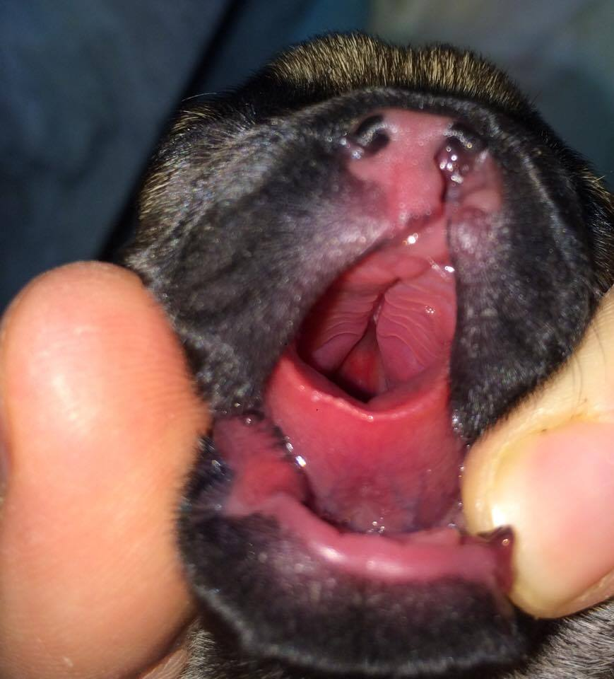

Picture 1
Cleft palate and cleft lip in a new born French bulldog
Source: Private picture

It is a genetically inherited disease and some breeds are more predisposed, like Chihuahua, brachycephalic breeds, Beagles and Cocker spaniels. External interferences also play a role in the development of the palate, like drugs, pollutants, and excess of certain vitamins or metabolic disturbances (F. Van den Berge et al., 2010). Dogs with palatine defects may be predisposed to middle ear diseases. When looking and the medical record of eight dogs with congenital palatine defects, five dogs had nasal discharge and seven dogs had radiographic signs of middle ear disease. One dog had an ipsilateral impairment of hearing detected by brainstem auditory evoked responses (S.P. Gregory, 2000).

The process where the palatal elevation and fusion happens, takes only a few minutes to a few hours. It is primarily the intrinsic factors of the composing tissues that ensures accumulation and hydration of hyaluronic acid that consequently result in swelling of the mesenchymal stroma and a decrease in mesenchyme density. Together with the palatal elevation and growth, theres is growth of the maxillary and mandibulary processes, which allow the tongue to slide down and forward (J. Lane and V. Kaartinen, 2014). In addition active and passive movement of the toungue, opening of the mouth and hyperextension of the neck are also crucial forces to retract the toungue ventrally and free space for the palatal fusion dorsal to the tongue (F. Van den Berge et al., 2010).

Teratogenic effects such as anabasine, an alkaloid related to nicotine, can interfere with the muscle contraction of the tongue, and consequently cause palatoschisis (F. Van den Berge et al., 2010). A specific type of cells called “Periderm” cells, is joined together by tight junctions and have an important role in controlling the adherence of the palatal shelves and epithelial differentiation. These cell make up a thin, one layered protective layer preventing aberrant adhesions. It is however important that these cells are lost at sites of fusion, for appropriate epithelial differentiation and adherence (J. Lane and V. Kaartinen, 2014).

2.2 Symptoms

Symptoms observed in affected newborns are nasal discharge, sneezing due to rhinitis and pharyngitis and the inability to swallow and create a vacuum suction. Suckled milk will enter the nasal cavity and run freely out the nostrils or into the nasopharynx. Coughing and regurgitation will be seen due to food particles in the respiratory tract. In a litter where there are some healthy and some affected puppies, it is obvious which puppies that is affected. The healthy puppies will quickly outgrow the sick and consequently be the first to get food from the dam. Eventually the affected animals will become undernutritioned, underdeveloped and most likely develop aspiration pneumonia. Due to the low amount of colostrum intake, their immune system will be lower than normal, which will make pneumonia more critical for these puppies.

2.3 Role of folic acid
Folic acid (Vitamin B9) is the synthetic form of folate. Folate occurs in many foods as dietary polyglutamyl folate, in dark green leafs and fruits among others. Folates in the foods are hydrolyzed to the monoglumate form in the gut, before entering the bloodstream it is further reduced to tetrahydrofolate (THF). Methylenetetrahydrofolate reductase (MTHFR) and vitamin B12 contribute in the folate metabolism, and a decreased level of these substances may lead to a disturbed folate metabolism and consequently an increase in homocysteine. A high level of homocysteine can interfere with the normal methylation of important developmental genes. It can also result in an increase of oxidative stress, cell damage and apoptosis. Binding of homocysteine to folate receptors on the placenta can provoke a maternal immune response, causing destruction of folate receptors to the fetus and consequently a decrease in folate transport (F. Van den Berge et al., 2010).
Folic acid plays a role in the prevention of neural tube defects, assist in the synthesis of nucleic acids, which are the precursors of making DNA and RNA by acting as a cofactor. It also has an important role in the repair and methylation of DNA (homocysteine to methionine). Folic acid is therefor very important for rapid cell division and growth. Folate deficiencies can lead to megaloblastosis and cell death, particularly in highly proliferative tissues, such as an embryo (F. Van den Berge et al., 2010).

2.4 Importance of Transforming Growth Factor β3 (TGF- β3)

TGF-β3 is one of the three closely related mammalian TGF-βs, which are multifunctional small proteins that control cellular proliferation, differentiation and migration (V. Kaartinen et al. 1997). They also play a role in the regulation of extracellular matrix deposition and epithelial-mesenchymal transformation. Studies have suggested that TGF-β3 is a very important factor during palatogenesis, cardiac morphogenesis, mammary gland development, wound healing and Meckel´s cartilage formation (G. Proetzel et al., 1995).
It has been done a study on the importance of TGF-β3 in palatogenesis in mice by using mice deficient in TGF- β3, proving that this factor has a role in palatal shelf fusion in both intrinsic and primary mechanism. The result suggested that TGF-β3, which is expressed abundantly by the medial edge epithelium (MEE), is necessary for the disappearance and adhesion of the MEE to ensure a normal fusion of the palatal shelves (G. Proetzel et al., 1995).

2.5 External harming effects of embryogenesis

2.5.1 Dioxin

Dioxin is a toxic compound that is formed by industrial processes like waste incineration where burning of chlorine-based chemical compounds with hydrocarbons is performed. It is one of the most toxic man made by-products that is highly persistent in the environment. The most toxic form of dioxin is 2,3,7,8-tetrachlorodibenzo-p-dioxin (TCDD). It is an extremely hazardous compound with biological effects including carcinogenesis, immune dysfunction, hepatotoxicity, thymic involution and reproductive toxicity to mention some.
TCDD acts through the aryl hydrocarbon receptor (AhR) in the embryonic palate resulting in disturbances in the epithelial cell proliferation and differentiation. It is also proven through experimental research that the synthetic glucocorticoid hydrocortisone (HC) has a potent, synergistic interaction with TCDD. It was observed that following administration of both HC and TCDD, the expression of both glucocorticoid receptors (GR) and AhR receptors increased (B. D. Abbott et al., 1994).

It has been performed studies on pregnant mice to prove the harming effect of TCDD in the embryonic palatal development. One group of pregnant mice were dosed on day 10 of gestation with 24 μg/kg TCDD and 5mg/kg folic acid, the other group were only dosed with 24 μg /kg TCDD. A control group was also established. The results showed that there were an incidence of 70,2% clefts in the group only treated with TCDD and 66,3% in the group treated with both TCDD and folic acid. RT-PCR results showed that TGF-b3 expression was down regulated compared to the control group.

This proves that supplementation of folic acid has no significant protection role against TCDD induced clefts, and that the TCDD actually repress TGF-b3 gene. Also an abnormal apoptosis was included by TCDD at the MEE during the early developmental stage (C. Li et al., 2014).

2.5.2 NSAIDs and Steroids

Mucopolysaccharides are important in the development of a normal palate. The elevation of the palatal shelves is most likely caused by an intrinsic turgor shelf force, by hydration of mesenchymal mucopolysaccharides. Some corticosteroids and non-steroidal anti-inflammatory drugs interfere with the synthesis of these mucopolysaccharides and the proliferation of mesenchymal cells, resulting in smaller palatal shelves that fail to fuse (F. Van den Berghe et al., 2010).
There is a drug in particular, acetylsalicylic acid (Aspirin), when administrated to dogs between day 23 and 30 after conception, which increases the risk for multiple malformations. The risk of malformation may be reduced by simultaneously administration of pyroxidine (vitamin B6) and cobalamine (vitamin B12). It has been proven that dexamethasone induces thickening of the MEE, preventing them from apoptosis and a formation of a continuous mesenchyme so that the two palatal shelves can fuse (F. Van den Berghe et al., 2010).
An experiment with corticosterone-induced cleft palate in mice was done. Different groups of mice were fed 30, 100 or 300 mg/kg/day casopitant on gestation day (GD) 6 to 15. Blood was collected on GD 13 to measure plasma adrenocorticotropic hormone and corticosterone concentrations. The results were that there was no evidence of developmental toxicity in mice fed 30 or 100 mg/kg/day, but 9% of the fetuses at 300 mg/kg/day had cleft palate (M.K. Ziejewski, et al., 2012).

2.5.3 Retinoic acid
Retinoic acid is a retinoid, a metabolite of retinol (vitamin A), and plays a role in the maintenance and differentiation of epithelial tissue, developing of the nervous system and notochord in embryos. It also contributes in immune competence and reproduction. Retinol is oxidized by enzymes in the body from all-trans retinol to all-trans-retinal and then an irreversible oxidation to all-trans-retinoic acid. Retinoids are also important for cell growth, immunologic function and visual function (R. Blomhoff and H. K. Blomhoff, 2016)
During the formation of the hard palate, chondrocyte proliferation and differentiation are fundamental processes. As vitamin A has a controlling influence over osteoblasts and osteoclasts, explains why excess of all-trans retinoic acid (atRA) has a teratogenic effect on palatogenesis. AtRA also inactivate several important intracellular receptors, leading to cellular damage. This will lead to hypoplasia of the palatal shelves with abnormal cartilage and bone formation (F. Van den Berghe et al., 2010).
After injecting pregnant mice with atRA, the effect on the palate differed depending on the gestation day (GD) when exposed. Mice that were exposed at GD 10 formed abnormally small palatal shelves, while after GD 12 the shelves had normal size, but fail to fuse as the medial cells proliferated and differentiated into nasal-like epithelium. AtRA exposure also altered the expression of important growth factors like TGF-a, TGF-β1 and TGF-β2. This alteration will cause a disturbance in proliferation, differentiation and expression of matrix proteins (Dr. B. D. Abbott and L. S. Birnbaum, 1990)

2.6 Internal harming effects

2.6.1. Uncontrolled diabetes mellitus
Hyperglycemic pregnant dams have a higher risk of giving birth to offspring with cleft palate. This has been established experimentally in mice and rats, where it has been shown that non-obese-diabetic (NOD) strains of mice, which become diabetic spontaneously, increase the frequency of neural tube defects up to 40%. One of the reasons that explain this is that the excess glucose concentration in the blood inhibits the uptake of important nutrients like inositol and arachidonic acid. These substances are important in prostaglandin production, PGE2 in particular. Prostaglandins stimulate the adenylate cyclase by increasing the intracellular level of cyclic adenosine monophosphate (cAMP) within the palatal tissues which is important for the MEE cell differentiation (C. Kappen, 2013).
Maternal hyperglycemia increases programmed cell death, which is one factor causing embryonic malformations. It is also associated with oxidative stress, lipid peroxidation and decreased antioxidant defense capacity (E. Reece et.al, 2005). So to avoid a reduction in arachidonic acid, supplementation of this has been proven to reduce glucose-induced defects. Antioxidants should also be supplemented since free radicals are associated with hyperglycemia (C. Kappen, 2013).

2.7 How to raise a puppy with cleft palate

When puppies are born, congenital defects such as cleft palate should be ruled out after birth. It is crucial that the newborn suckle milk and gain all the necessary immunoglobulins, vitamins and other nutrients necessary for a healthy growth. If a puppy is born with cleft palate that remain undiscovered, the puppy would first of all not receive the necessary nutrients to grow and develop a vital immune system. And as mentioned before, the inevitable risk for aspiration pneumonia. Due to the opening slit between oral and nasal cavity, the function of suction vacuum is lost, and the newborn cannot suckle, breath nor swallow properly.

2.7.1 Cleft palate case

A female French bulldog named “Bambi” was delivered with C-section with an average weight (190 gram). The mother was 1,5 years old and this was her first litter. In the same litter 5 males were also born, all of them healthy. The veterinarian discovered the cleft palate and cleft lip immediately, and the owner was informed about this defect.

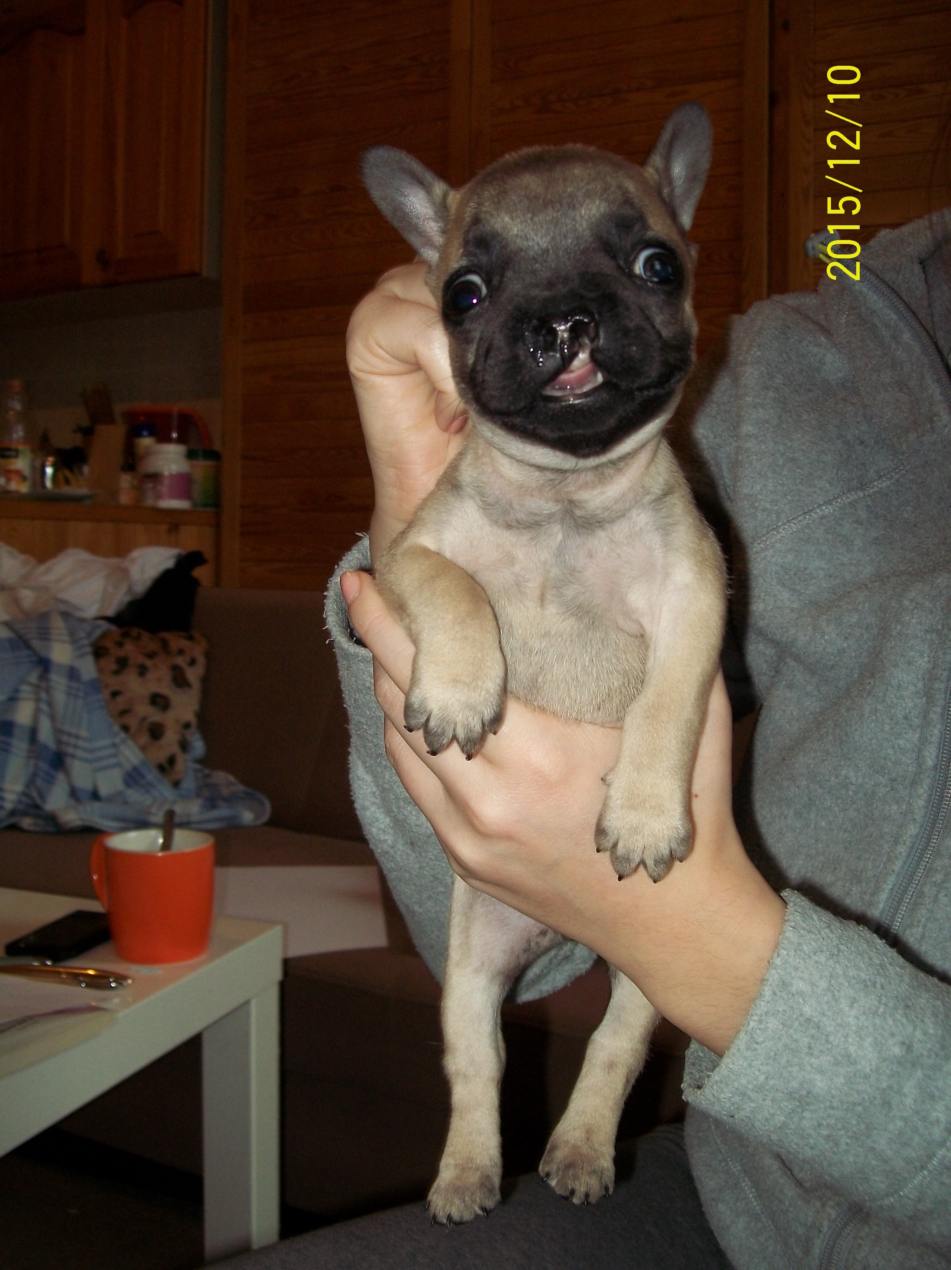

Picture 2
”Bambi” at 2,5 months with cleft lip on the left side
Source: Prive picture

Since the owner didn´t want to use all the extra time and energy to raise this puppy, she told the veterinarian to euthanize it. The veterinarian decided to try to raise the puppy with help from a student.

A gastric tube was inserted into the stomach, and the puppy was fed every three hours, day and night, with “Happy Dog” milk replacer. After 3 weeks, the feeding was decreased to every 4 hours. The growth rate was extremely slow, and after 7,5 weeks old she had only gained 185 gram. A small amount of solid food was added to the diet when the puppy was 4 weeks old. With such slow growing rate, there was a great risk that the puppy wouldn’t survive. The diet was changed to Royal Canine milk replacer and the growth rate accelerated. At 10 weeks old she weighed 1,7 kg. When the puppy had reached 5 months the weight was 5,5 kg. Normal weight of a healthy puppy at 5 months is 7-9 kg. Water was given in a hanging drinking bottle (for rabbits and rodents) to aid a downward passage of the water up until 5 months of age.

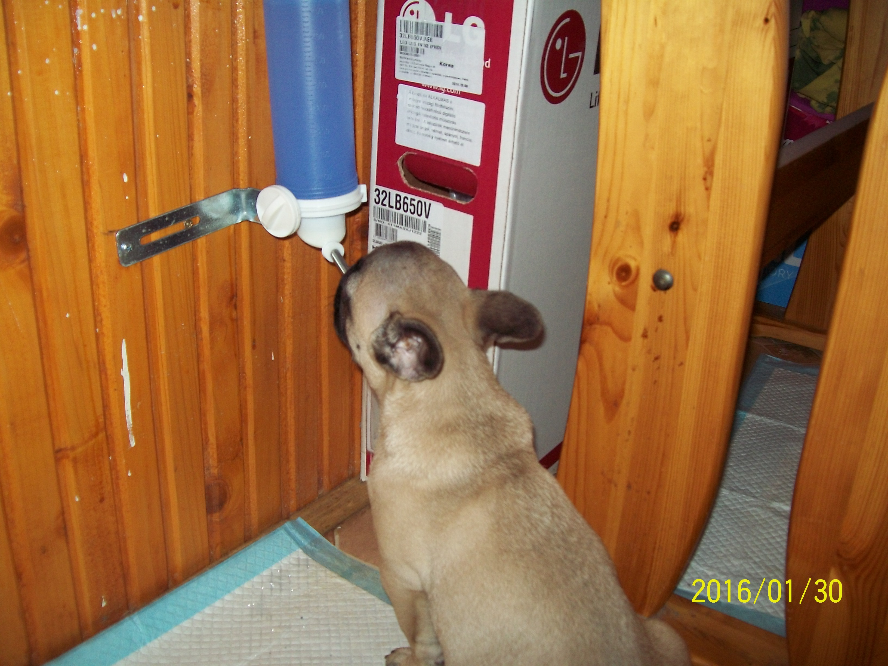

Picture 3
”Bambi” 4 months old drinking from a hanging drinking bottle
Source: Private picture

Fortunately the cleft was growing more and more together as the puppy grew older. When the new owner took over the care for the puppy at 5 months of age, the opening was almost closed and she was fed normal and could now drink from a water bowl. She had her first oestrus when she was 9 months old. After 1 year the palatoschisis was completely healed and she weighed 11kg, which is a normal weight for a female French bulldog.

This is proof that a defect like this, that may cause fatal consequences for a newborn puppy, may result in a healthy and normal dog. It is understandable that the job in thriving a newborn with cleft palate is too time consuming for some people. We must also acknowledge that not all cases have a happy ending. But when we chose to breed dogs, we must also face the consequences of the possibility that some offspring carry diseases and defects, just like humans. As a veterinarian it is important to do what is best for the animals, even though it takes time and effort.

2.8 Treatment

2.8.1 Overlapping flap technique

Surgical treatment is necessary to separate the oral and nasal cavity and ensure a normal and worthy life of a dog with cleft palate, if it doesn´t close by itself. But before performing a surgical intervention, it is important to consider the limited vascularity, thin layer of mucosa and the rigid structure of the hard palate (D. Isik et al., 2011).

One possibility to close a cleft palate is the overlapping flap technique (Picture 2). An incision is made on one side at the edge of the cleft separating the oral and nasal mucosa. A mucoperiosteal rotation flap should be made on the other side large enough to cover the defect with its base hinged at the margin of the palatal defect. The incision of the flap should be done parallel to the dental arcade and should be 2-4 mm larger than the defect. The flap is lifted up, rotated over to the other side and placed into the mucoperiosteal flap on the opposite side. Tie a series of horizontal mattress sutures to secure the flaps in position. With time, the flaps will grow together and the wound where the flap was cut will heal. Continue the incisions caudally into the soft palate and close in three layers; nasal mucosa, palatal muscles and oral mucosa

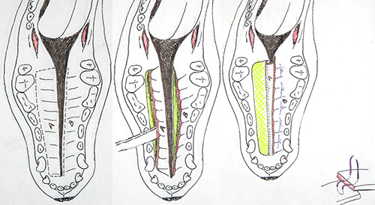

Picture 4
Illustration of the overlapping flap technique
Source: https://www.vet.upenn.edu/about/press-room/publications/penn-vet-extra/penn-vet-extra-september-2015/a-tale-of-two-palates
Accessed: 19/11 2016

When performing this type of surgery, it is important to keep in mind that if the surgery is unsuccessful, it will be even more difficult to perform it the second time due to scar tissue with poor vascularity. This will make it harder to create tissue flaps that can grow into each other. The owner should be informed that it might be necessary with more than one surgery to completely close large cleft palates.

2.8.2 Sliding bipedicle flap repair

When performing this type of repair you have to make bilateral releasing incisions along the margin of the dental arcade. Lift up the two mucoperiosteal layers with a periosteal elevator, remember to be careful for the palatine arteries. Appose the nasal mucosal edges at the margin of the cleft with interrupted sutures. Slide the mucoperiosteal flaps across the defect and appose them with single interrupted sutures. The denuded hard palate on each side should heal by secondary intention. The cleft is now closed with two layers, both nasal and oral cavity.

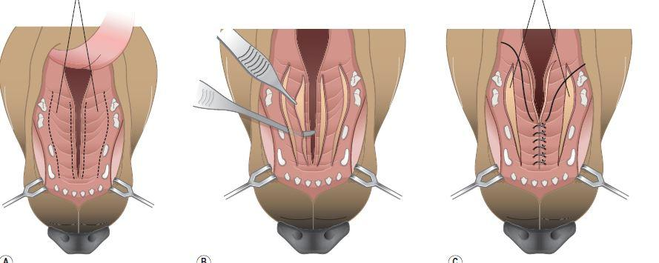
Picture 5
Sliding bipedicle flap surgery of a secondary cleft palate
Source: https://www.studyblue.com/notes/note/n/verstraete-ch36-deck2-cleft-lip-repair/deck/13444453
Accessed: 17/11 2016

2.8.3 Postoperative care and complications

To avoid rupture of the sutures, feed only soft food for 2 weeks and prevent chewing on hard toys, sticks, bones etc. Gastrostomy feeding for 7-14 days may be done to facilitate healing. A postoperative control should be done after 14 days.
Opening of the sutures due to mechanical trauma or too high tension and consequently incomplete healing of the oronasal fistula is the most common complications. Healing may also be delayed if the blood supply is poor or the tissue is traumatized. If the veterinarian suggest a second surgery, this should be done after 4-6 weeks to allow tissues to revascularize.

2.8.4 Prognosis

The prognosis is good if the surgery is successful, although several surgeries may be necessary. If a small fistula persists, or large defects are not repaired, the patient is likely to have a chronic rhinitis and aspiration pneumonia, and the prognosis is guarded. Regarding the animals with clefts that grow together, the prognosis is good.

2.9 Other congenital diseases

2.9.1 PRA - Progressive retinal atrophy

Progressive retinal atrophy is an inherited disease where there is a gradual destruction of photoreceptors and the layers of the retina. This will over time eventually result in loss of vision. In human it is called retinitis pigmentosa. Rods and cones are photoreceptor cells situated in the retina, and are responsible for light and colour transmission through depolarization and release of glutamate neurotransmitters. The neurotransmitters hyperpolarize bipolar cells and transmit signals from photoreceptor cells to ganglion cells. Rods are highly light sensitive and work best in dim light, and rods are responsible for colour vision and function best in moderately bright light (M. Joesch, M. Meister, 2016)
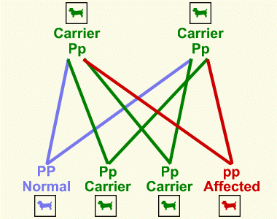

Picture 6
Recessive inheritance pattern of PRA
Source: http://www.bregorreyglens.co.uk/pra.html
Accessed: 15/11 2016

Inherited retinal diseases compromise a group of hereditary degenerative lesions in the retina. A central and a general form can be differentiated. The generalized form (gPRA) involves dysplasia and atrophy of the rods and cones whereas the central form is characterized by accumulation of pigment in the layer of pigmented epithelium of the retina and atrophy of the rods and cones (F.C. Stades, 1982).
By using single nucleotide polymorphism (SNP) arrays and fine mapping of the possible regions in the genome, a group of scientist have discovered that the gPRA is assigned to the canine chromosome 16 (R. Kropatsch et al. 2010). A form of the gPRA has been investigated in Miniature Longhaired Dachshund, and a segregated pattern in litters from affected parents was consistent with simple autosomal recessive inheritance (R. Curtis and KC. Barnett, 1993). It is however been seen a sex linked inheritance on the X chromosome in a Siberian husky tribe and a recessive and dominant inheritance in Abyssiner cats (E. Bjerkås, 1998)
The first symptoms of PRA are nyctalopia, that will gradually develop into totally blindness, tunnel vision, dilated pupils with a decreased pupillary reflex, atrophy of the retinal blood supply and changes in the granular appearance of the tapetal fundus. Later on an irregular loss of pigment in the non-tapetal fundus and optic atrophy can be seen. The age of onset of symptoms vary with the different breeds. For example a Tibet spaniel will show symptoms from 2-4 years old, while a Labrador can be 5-8 when the first symptoms are seen. It is important to know that the disease doesn´t cause directly pain for the dog, but secondary changes might cause problems. Breeds prone to inherit PRA in Norway include retrievers, Cocker spaniel, poodle, English setter, Tibetan spaniel, Papillon, Lhasa Apso and Akita inu (E. Bjerkås, 1998).
Scientists have discovered the close related genotype-phenotype correlation and similarities in the ocular anatomy to humans, which makes screening of purebred dog population helpful in the development of human therapy. A group of 324 Swedish Vallhund dogs in seven different countries where examined and they were able to describe a new and different form of PRA, which was characterized by mutlifocal appearance of red and brown discoloration of the tapetal fundus, and also thinning of the retina over time (A.E. Cooper et al., 2014)
On the basis of the clinical signs, appearance of the ocular fundus and visual deficits they suggested three stages of the disease. There was evidence from electroretinography of a gradual loss of both rod and cone photoreceptor function in both stage 2 and 3. In a few dogs that suffered from pronounced vision loss, nyctalopia occured in late stage 2, and a decreased day-vision in stage 3. Histological examinations confirmed the loss of photoreceptor cells at stage 3 was evident in conjunction with accumulation of autofluorescent material in the adjacent retinal pigment epithelium (A.E. Cooper et al., 2014).
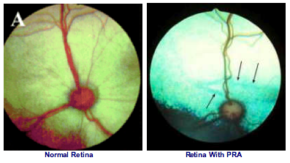

Picture 7
Picture ”A” is a healthy retina. Arrows on the right picture are showing degenerated blood vessels and a much brighter reflection in a PRA retina
Source: http://www.bobtownpetclinic.com/news/2015/7/24/case-of-the-week
Accessed: 15/11 2016

It was suggested that PRA is an autosomal-recessive inherited disease, but mutation in six known canine retinal degeneration genes as well as hypovitaminosis E was excluded as a possible reason for the disease. It was suggested that both genetic and/or environmental factors contributed to the disease due to the great variability in the age of onset and rate of progression of the disease (A.E. Cooper et al., 2014).
This is unfortunately a disease that cannot be cured, and the best way to avoid congenital inheritance is to avoid breeding the affected dogs. In breeds prone to develop PRA, or if the disease is to be suspected, an electroretinography should be performed to discover the disease at an early stage (E. Bjerkås, 1998). It is also possible to do a screening of the parental line DNA by taking a buccal swab sample and investigates the genes involved in the inheritance of PRA. In this way it is possible to rule out the genetics causing this retinal lesions.

2.9.2 Von Willebrand´s disease (vWD)

This disease is a mild inherited and the most common hereditary hemostatic defect in domestic animals (M. A. Thrall et al., 2004). It is a dominant autosomal inherited trait, which cause a high morbidity but a low mortality (W. J. Dodds, 1984). This coagulopathy is often confused with Hemophilia A, because both diseases have a defect of coagulation factor VIII. Hemophilia A has a deficiency of coagulation factor VIII:C but vWS has a strictly defect of platelet function due to defects of factor VIII. It is also a difference in the inheritance, where Hemofilia A is a sex-linked trait and occur more frequently in male patients, and vWD is, as described before, has an autosomal defect which occur equally in male and female patients (M. A. Thrall et al., 2004).

Test | Hemophilia A | von Willebrand Disease
Activated partial thromboplastin time | Prolonged | Normal to prolonged
Prothrombin time | Nomal | Normal
Activated coagulation time | Prolonged | Normal to prolonged
Bleeding time | Normal | Prolonged
Fibrinogen | Normal | Normal
Fibrin(ogen) degradation products | <10μg/mL | <10μg/mL
Platelet number | Normal | Normal
Von Wilebrand factor concentration | Normal | Decreased
Factor VIII:C activity | Decreased | Normal to decreased
Table 1
Expected coagulation parameter results in Hemophilia A or von Willebrand Disease

Von Willebrands factor is a glycoprotein coagulation factor in the intrinsic coagulation cascade. It is required for platelet adhesion to subendothelium and it binds to surface glycoprotein Ib of platelets and to IIb/IIIa that usually binds fibrinogen (M. A. Thrall et al., 2004). If the plasma level is low, absent or defective of von Willebrands factor, the platelets does not recognize and respond to collagen in the basement membranes and extravascular tissues and are therefore not activated. Abnormalities in this particular coagulation factor in the concentration, structure or function gives rise to this hemostasis disorder, resulting in a prolonged bleeding time. Hemophilia does not show a prolonged bleeding time, as shown in “Table 1”. Typical clinical signs seen in this disease include epistaxis, hematuria, gingival and genital mucosal bleeding and a prolonged bleeding from cuts and wounds (W.J. Dodds, 1984).

VWD can be classified according to partial or complete deficiencies and from qualitative defects. Type 1 is a partial lack of the von Willebrands Factor (vWF) whereas type 3 is complete lack. Type 2 has qualitative defects and can be further divided into subtype A, B, N and M described in the table below (J. J. Alastair et al., 2004):

Type | Description
1 | Partial quantitative deficiency of vWF
2 | Qualitative vWF defects
2A | Decreased vWF-dependent platelet adhesion and a selective deficiency of high-molecular-weight vWF multimers
2B | Increased affinity for platelet glycoprotein Ib
2M | Decreased vWF-dependent platelet adhesion without a selective deficiency of high-molecular-weight vWF mutlimers
2N | Markedly decreased binding affinity for factor VIII
3 | Virtually complete deficiency of vWF
Table 2
Descriptions of the different types of von Willebrand´s disease

The severity of the first group is variable, the second group is moderate to severe and the third group is a severe condition. Affected breeds of group 1 include: Welsh corgi, Doberman pinscher, German shepherd, golden retriever, Akita, greyhound, Irish wolfhound, schnauzer and poodle. German shorthaired pointer and German wirehaired pointer is a typical candidate for the second type and Scottish terrier, Chesapeake Bay retrievers, pit bull, Rottweiler, Dutch kooiker and Shetland sheepdog are more prone for the third type (M. A. Thrall et al., 2004).

To be able to diagnose and a successful treatment it is important to know the difference between the types of vWD. This may be a challenge due to the changing phenotype and mutation character of the disease (J. E. Sadler et al., 2006). Plasma concentrations of vWF can be measured by enzyme-linked immunosorbent assay (ELISA), where the result is given in a percentage of the normal concentration in the plasma. Stimulation of the release of vWF can be done by administration of Desmopressin acetate (DDAVP; deamino 8-D-arginine vasopressin) (M. A. Thrall et al., 2004). Invasive surgery, jugular catheterization and drugs with antiplatelet effect should be avoided in vWD patients (S. J. Ettinger and E. C. Feldman, 2005).

After establishing the type and severity of vWD, and possibly concurrent diseases, it is possible to find a proper treatment for the patient. If treated correctly there are great possibilities for the dog to live a normal life with this congenital disease. Breeders must take caution in breeding carriers, due to the risk of producing clinically affected offspring with a severe type III vWD. Dogs with an unnoticed vWD, may suffer massive bleedings during surgical procedures, it is therefore important to establish if they are affected before any surgical intervention.

2.9.3 Hip Dysplasia

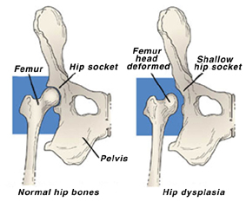
This is a common congenital disorder that is identified as a source of pain, functional impairment and an increased risk for development of osteoarthritis (A. Troelsen et al., 2007). Hip dysplasia (HD) is a developing malformation of the coxofemoral joint characterized by subluxation or complete luxation of the femoral head. When the coxofemoral joint is completely luxated, there is a complete separation between the acetabulum and the femoral head, whereas in a subluxation there is a partial or incomplete separation (T. W. Fossum et al., 2007).

Picture 8
Illustration of a normal hip joint and a luxated hip dysplasia joint
Source: http://www.dogbreedhealth.com/canine-hip-dysplasia-hd/
Accessed: 15/11 2016

It is proven that the nature of HD is both hereditary and due to environmental factors, but primarily hereditary. Excessive nutritional intake and a rapid growth can cause a disparity in the development of the supporting soft tissue around the coxofemoral joint. Synovitis in the joint due to i.e. mild trauma leads to an increased volume of joint fluids, which disturbs joint stability due to the suction like action produced by a thin layer of normal synovial fluid between the articular surfaces. These are factors that contribute to the joint loosening and subsequent subluxation (T. W. Fossum et al., 2007).

When a subluxation occurs in the coxofemoral joint, the fibrous joint capsule is stretched, which is painful. The acetabular bone is easily deformed by this continuous dorsal luxation of the femoral head (See “Picture 9”). When the femoral head is tilted from a normal horizontal plane to a more vertical plane the surface area of articulation is reduces which will change the weight bearing to a smaller area in the joint. This can result in fractures of the acetabular trabecular bone leading to an exacerbation of the pain and lameness (T. W. Fossum et al., 2007).

The physiological response of the body when a joint subluxates over a certain period of time are proliferative fibroplasia of the joint capsule and increased trabecular bone thickness. These are defence mechanisms of the body trying to stabilize the joint and keep it in place. Unfortunately this will lead to a reduced area of articulation and wearing down of articular cartilage, exposure of subchondral pain fibers, and lameness. In juvenile dogs HD is painful due to exposure of pain fibers in subchondral bone, whereas in older dog it is the stretching of soft tissue that is causing the pain (T. W. Fossum et al., 2007).

It is possible to determine HD with x-ray imaging, but clinical symptoms may also reveal this disease. Symptoms in young patients include exercise intolerance, difficulties with rising after rest and lameness. As the animals grow older, they develop additional clinical signs indicating hip joint pain. Due to the progressive and degenerative joint disease (DJD), atrophy of the pelvic musculature and a waddling gait of the rear limbs can be seen. It is normal to evaluate patients that are likely to have HD for the first time at 5 to 10 months of age. Typical findings at this point are pain during extension, external rotation and abduction of the hip joint. A poorly developed pelvic musculature is also likely to be observed. Physical examination in older animals includes pain during hip joint extension, reduced range of motion and pelvic muscle atrophy. There is usually no laxity due to the proliferative fibroplasia response in the joint capsule, but crepitus can be detected when manipulating the joint (T. W. Fossum et al., 2007).

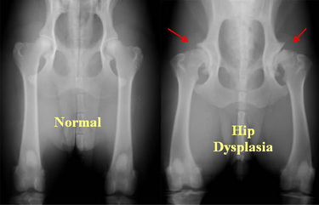

Picture 9
X-ray of normal hip and hip dysplasia, red arrows showing a deformed and flattened acetabulum
Source: http://www.azpetscan.com/pet-scan-blog-the-inner-pet/hip-dysplasia-in-dogs-pets-dogs-hip_dysplasia-veterinary,
Accessed: 15/11 2016

Dogs that is intended to be used in breeding programs needs to be screened for HD. An x-ray is taken in a ventrodorsal view of the pelvis with the rear limbs stretched. It is important that the legs are stressed in an extended inward position to center the patellae over the trochlear grooves (shown in “Picture 9”). After the pictures are taken they are sent and evaluated by a professional imaging diagnostician (T. W. Fossum et al., 2007). In Scandinavia there are 5 diagnostic degrees; A, B, C, D and E. A and B are “free” of HD, C is a “weak” degree and E is a strong HD.

There has been done an evaluation of the risk factors for degenerative joint diseases associated with HD in German shepherds, Golden Retrievers, Labrador retrievers and Rottweilers. The objectives were to determine whether age, breed, sex, weight or distraction index was associated with the risk that dogs of the 4 mentioned breeds would have radiographic evidence of DJD associated with HD. 15 742 dogs were evaluated radiographically. The results showed that weight and distraction index were significant risk factors for DJD in all breeds. German Shepherd dogs had the worst outcome with a 4,95 times higher risk of having DJD than the other 3 breeds combined. It was also proven that the probability of having DJD increases with age (G. K. Smith et al., 2001).

Surgical and conservative options are available for dogs with HD. It is however an increased prognosis for juvenile animals treated surgically for the long-term acceptable clinical function. Approximately 25% of juvenile dogs treated conservatively require further medical or surgical interventions at some point in life. Conservative treatment is ineffective in older patients so surgery is indicated. It is also possible to perform surgery on juvenile dogs meant for sport or if the owner wishes to slow down the DJD progression (T. W. Fossum et al., 2007).

Physical rehabilitation like swimming or walking on treadmill in water is helpful in maintaining range of motion and strengthens the periarticular structures, which can stabilize the area around the joint. Anti-inflammatory drugs like NSAIDS are indicated to relieve pain, but make sure the patient get enough rest, even though it appears like the dog has returned to normal function. Remember to always administer the lowest effective dose (T. W. Fossum et al., 2007). A very important aspect in managing this DJD is weight management. Inform the owner to feed bulk diets low in fat and protein, supplement with omega-3 fatty acids and glucosamine/chondroitin and keep the dog active.

2.9.4 Cryptorchidism

Cryptorchidism is a condition where one or both testes fail to descend into the scrotum. The testes may remain in the inguinal canal or in the abdomen. This is a congenital defect from an autosomal recessive gene that usually occurs in small and inbred breeds. It is in fact the most common genital defect in dogs (J. H. Moon et al., 2014). A unilateral cryptorchid male dog may be fertile, but should not be bred to decrease the incidence of the defect. It is possible to help the descending of the testes by massage of the inguinal canal. Treatments with androgen and gonadotropin have been tried but with little success (S.E. Romagnoli, 1991). If the testes fail to descend either uni- or bilateral it is advised to treat with a bilateral orchidectomy due to the risk of testicular neoplasia such as seminomas and Sertoli cell tumours (T. W. Fossum et al., 2007)

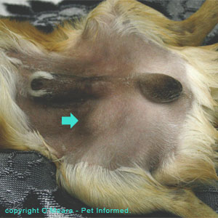

Picture 10
A Pomeranian dog with the right testis in the inguinal channel (Blue arrow)
Source: http://www.pet-informed-veterinary-advice-online.com/cryptorchidism.html
Accessed: 7/11 2016

To look further into the pathology of the cryptorchid testes, twelve Miniature Schnauzer dogs were investigated. Five cases were unilateral, all on the right side, and the rest was bilateral. Eight of these dogs testes was studied anatomically. The testes were separated from the epididymides and both were weighed. All the testes that were retained on the right side were smaller than it´s counterparts. All the ectopic testes were in abdominal position except one. Looking closer on the morphologic appearance of the epididymis to the abdominal testes, it was very primitive in the bilateral cases, but almost normal in the unilateral cases. It was a clear connection between the degree of inbreeding and bilateral cases, which gives good evidence about the hereditary nature of cryptorchidism in this particular breed (V. S. Cox et al., 1978).

It is clear that the histological picture is different in testes that lays in the scrotal sac compared to the other remaining in the abdomen or inguinal canal. A study has investigated this phenomenon, and observed in hematoxylin and eosin stained sections that there are a significant reduction in number of spermatogonia, spermatocytes and spermatids. The epididymis was also significantly smaller in size, however the proliferative activity was increased in the duct. It was also proven that the Sertoli cells were increased in the cryptorchid testis. This may be one reason for the increased risk for Sertoli cell cancer in cryptorchid testes (J. H. Moon et al., 2014)

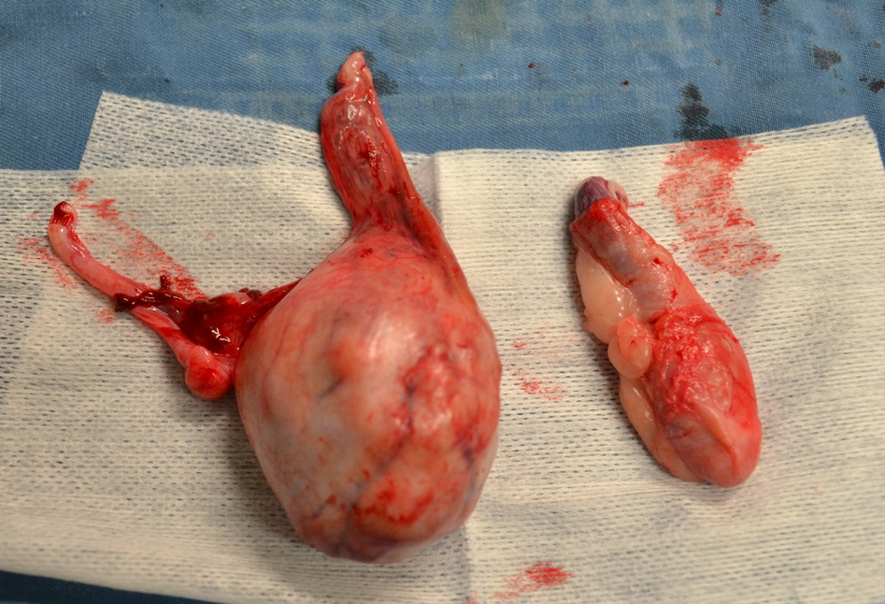

Picture 11
Sertoli cell tumor on the left, atrophied testicle on the right
Source: http://www.australindvet.com.au/testicular-cancer-and-sertoli-cell-tumor-in-a-dog-benefits-of-castration.html
Accessed: 8.11.2016

The testes are usually complete descent by day 10 after birth, but it is advised to wait until 6 months of age before declaring a dog cryptorchid. The reason for this is that in many cases the inguinal ring is closed, precluding movement of the testis in to the inguinal canal and scrotum. Testis of a young puppy may also move between the scrotum and inguinal canal due to its small size and soft texture, often in association with stress or fear. As mentioned before, there is no spermatogenesis in cryptorchid testis, there is however a testosterone production which is the reason for sexual behaviour and the ability to achieve erection (M. Memon and A. Tibary, 2001).

Incidences of cryptorchidism in dogs range from 1,2-10%, where the top ten breeds affected are Toy poodles, Pomeranian, Yorkshire terrier, Miniature dachshund, Cairn terrier, Chihuahua, Maltese, Boxer, Pekingese and English bulldog (M. Memon and A. Tibary, 2001). To diagnose a cryptorchid dog, careful palpation of the scrotum should be performed. It is possible to palpate a testis in the inguinal canal but more difficult if it is situated in the abdomen. Cryptorchidism may be diagnosed by using Human Chorionic Gonadotrophin (HCG) or Gonadotropin Releasing Hormone (GnRH) Stimulation Test to induce a measurable testosterone increase. Blood is drawn before and 60 minutes after injection of GnRH. If the testosterone level is increased in the latter blood sample, it is an indication for a cryptorchid dog (M. Memon and A. Tibary, 2001).

A castrated cryptorchid dog can live a happy life, not being affected by the lack of testes. It is possible though that the owner experience mood changes in their dog´s behaviour after castration, most likely because of hormone imbalance. But in most cases, a successful result is achieved after removing of both testes. It is important to inform breeders not to use a cryptorchid dog for breeding, as this is a trait that is unwanted.

2.9.5 Patent ductus arteriosus (PDA)

This condition has been reported in veterinary literature to be one of the most common congenital cardiac defects. Special for this disease is the sex predisposition where females are more prone than males (3:1), regardless of breed. It has also been suggested that it has an autosomal dominant mode of inheritance (V.L. Fuentes and S. Swift, 1998). In the embryo the ductus arteriosus is an essential fetal structure that connects the proximal descending aorta to the roof of the main pulmonary artery. Approximately 65% of the cardiac output is from the right ventricle, but only 5-10% of this blood passes trough the lungs. The rest goes through ductus arteriosus and into the descending aorta. This is a vital function for the normal fetal development and to divert most of the blood away from the high-resistance pulmonary circulation (D. J. Schneider and J. W. Moore, 2006).

Many factors are preventing the premature closing of the ductus arteriosus. The most important is the low fetal oxygen tension and cyclooxygenase-mediated products of arachidonic acid, primarily prostaglandin (PGE2) and prostacyclin (PGI2). These two substances cause vasodilation in the ductus arteriosus be interacting with ductal prostanoid receptors. The oxygen tension increases abruptly after birth, which will inhibit ductal smooth muscle voltage-dependent potassium channels and consequently result in an influx of calcium and ductal constriction. The wall of the duct will thicken due to contraction of medial smooth muscle fibres, the lumen will narrow and the duct will shorten (D. J. Schneider and J. W. Moore, 2006).

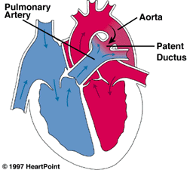

Picture 12
Illustration of a patent ductus arteriosus
HeartPoint
Source: http://www.heartpoint.com/congpda.html
Accessed: 5/11 2016
A complete closure usually occurs within 24 to 48 hours after birth. During the next couple of weeks the endothelium will fold and with subintimal disruption and proliferation will result in fibrosis and a permanent seal. This fibrous band lacking a lumen is now called the ligamentum arteriosum (D. J. Schneider and J. W. Moore, 2006). When this ligament fails to develop and the duct persists, there will be a vascular connection with a shunt from aorta to the pulmonary artery in both systole and diastole. As a result from this, there will be an overcirculation of the lungs and simultaneously an overload of the left atrium and ventricle. The left side of the heart will try to compensate for the lost volume to the pulmonary artery and most likely develop a left-sided heart failure. Secondary mitral incompetence may develop as a result from the left ventricular dilation. In an untreated, long lasting case of PDA myocardial failure may occur and the establishment of atrial fibrillation due to the enlarged left atrium (V.L. Fuentes and S. Swift, 1998).

Patent Ductus Arteriosus
Radiography | LA enlargement (2-3 o´clock)  LV enlargement  Dilated pulmonic trunk on DV view (1-2 o´clock)  Dilated descending aorta (12-1 o´clock)  Pulmonary overcirculation
Electrocardiography | Wide P waves (P mitrale)  Tall R waves (> 3.0 mV in dogs)  Various arrhythmias are possible – most commonly atrial fibrillation
2D and M-mode Echocardiography | LA enlargement  LV dilation with eccentric left ventricular hypertrophy  Dilated main pulmonary trunk  Ductus may be imaged with difficulty between main pulmonary arteries and descending aorta
Doppler Echocardiography | Diastolic turbulent flow in main pulmonary artery  Continuous turbulent flow at bifurcation of pulmonary trunk and in descending aorta  Ductus may be easily imaged with colour flow mapping  Mitral regurgitation is common
Table 3
PDA investigations

It is necessary to mention that a right-to-left shunt can occur, if a pulmonary hypertension is present. Blood will flow from pulmonary circulation to the systemic circulation if the pulmonary artery pressure exceeds the aortic pressure. As a result of this de-oxygenated blood will pass to the caudal parts of the body. This de-oxygenated blood will not affect the cranial parts of the body since the ductus arteriosus arise from the descending aorta, and the cranial parts are supplied from the ascending aorta. Cyanosis can consequently be observed in the mucous membranes of the vulva or prepuce. (V.L. Fuentes and S. Swift, 1998).

It is important to do a proper examination with thorough auscultation when owners arrive with their puppies for vaccination. Some affected puppies will present left-sided heart failure with pulmonary oedema. The murmur can be heard with maximal intensity at the left heart base as a machinery murmur often associated with a precordial thrill. A `water-hammer` pulse can often be felt in the femoral pulse due to the blood escape in systole to the ductus. Clinical signs such as shortness of breath and coughing could be signs of left-sided heart failure (V.L. Fuentes and S. Swift, 1998). It can be hard for a person who hasn’t trained enough to hear the abnormal heart sounds. But to diagnose at an early stage it is important that a competent person examine and discover this congenital defect as early as possible.

PDA can be surgically managed by a double ligation of the ductus. Left sided heart failure and irreversible myocardial damage may occur if not discovered and treated at an early stage. It is possible that some PDAs close spontaneously but this is not well documented in literature. The disease can be managed with diuretics, arteriodilators or angiotensin converting enzyme (ACE) to reduce the myocardial wall stress in patients not candidates for surgery (V.L. Fuentes and S. Swift, 1998).

3 Summary

In the study of congenital diseases, it is clear that there is a complexity in the pattern of inheritance. Embryogenesis is a detailed and fragile development of a living organism that can easily be disturbed. There are many factors that can influence the formation of a growing fetus, some that are out of our control and some we are able to prevent. Luckily, the body as an organism has adapted and learned to eliminate some of these hazards, even before birth.

By doing research on the mechanism of effect that different substances have on the body, both medical and environmental, is has become possible to understand how the body works. It is clear that without research, it wouldn’t be possible to know as much as we do today. And with this detailed knowledge it is possible to prevent and cure diseases, to know e.g. how dangerous environmental pollution is to the body and how important certain vitamins and intrinsic factors are. Even though a disease is most likely genetically inherited, conservative treatment and knowledge helps us in finding a way for the animal to live with the disease.

Cleft palate is a physical congenital disease, leading to secondary malnutrition and inflammations. By handling the primary problem correctly, the secondary problems will disappear. The French bulldog “Bambi” is a living proof that a congenital disease can be treated and the outcome is a healthy dog. Breeders should know about the diseases that may occur and the possibilities to deal with them, especially in brachycephalic breeds that are particularly prone for genetic disorders.

In this thesis I have understood more about the physiologic interactions in the body and the complexity of how everything is linked together, both inside an organism and how environmental factors can interfere. I have learned the importance of research and experiments to gain vital information about the tiny details that can cause devastating results. Most important of all, I have learned important and interesting facts about common diseases that I will use in my future as a veterinarian.

4 Bibliography

A
Abbot B. D., Perdrew G. H., Buckalew A.R., Birnbaum L.S. (1994). Interactive regulation of Ah and glucocorticoid receptors in the synergistic induction of cleft palate by 2,3,7,8-tetrachlorodebezo-p-dioxin and hydrocortisone, North-Carolina USA, Toxicology and applied Pharmacology, Sep 128(1) 138-150

Abbot B. D. And Birnbaum L. S. (1990). Retinoic acid-induced alterations in the expression of growth factors in embryonic mouse palatal shelves, Birth defects research, Dec 42(6), 597-610

Alastair J. J., Wood M. D. (2004), Treatment of von Willebrand´s Disease, Milan, The New England Journal of Medicine, 351, 683-694

B
Berghe F. Van den, Cornillie P., Stegen L., Goethem B. Van, Simoens P. (2010). Palatoschisis in the dog: developmental mechanisms and etiology, Merelbeke Belgium, Vlaams Diergeneeskundig tijdschrift, 79, 117-123

Bjerkås E. (1998), Veterinær Oftalmologi, Tell forlag, 144-145 p.

Blomhoff R. And Blomhoff H. K. (2006), Overview of retinoid metabolism and function, Oslo, Journal of neurobiology Jun 66(7), 606-630

C
Claudia K. (2013). Modeling anterior development in mice: Diet as modulator of risk for neural tube defects, LA, American journal of medical genetics Nov 163(4), 333-356

Source: https://www.studyblue.com/notes/note/n/verstraete-ch36-deck2-cleft-lip-repair/deck/13444453
Accessed: 17/11 2016

Cooper A. E., Ahonen S., Rowland J.S., Duncan A., Seppälä E. H., Vanhapelto P., Lohi H., Komáromy A. M. (2014). A novel form of progressive retinal atrophy in Swedish vallhund dogs, PLoS Sep 8, 9

Cooper H. K. Jr., Mattern G. W. (1971), Genetic studies of cleft lip and palate in dogs, Birth defects Original Article Series, 7(7), 98-100

Cox V. S., Wallace L. J., Jessen C. R. (1978), An anatomic and genetic study of canine cryptorchidism, British defect research, 18(2), 233-240

Source: http://www.australindvet.com.au/testicular-cancer-and-sertoli-cell-tumor-in-a-dog-benefits-of-castration.html
Accessed: 8/11 2016

Source: http://www.pet-informed-veterinary-advice-online.com/cryptorchidism.html
Accessed: 7/11 2016

Curtis R., Barnett K.C. (1993). Progressive retinal atrophy in miniature longharied dachshund dogs, Suffolk, The British Veterinary Journal, Jan-Feb 149(1), 71-85

D
Dodds W. J. (1984), Von Willebrand´s disease in dogs, USA, Modern veterinary practice, 65(9), 681-686

E
Ettinger S. J., Feldman E. C., 2005, Textbook of Veterinary Internal Medicine, Diseases of the Dog and Cat, vol. 2, Missouri, 1928-1929

F
Fuentes V. L. and Swift S, 1998, Manual of Small Animal Cardiorespiratory Medicine and Surgery, Cheltenham, British Small Animal Veterinary Association, 189-193

Fossum T. W, Hedlund C. S., Johnson A. L., Schulz K. S., Seim H., B, Willard M. D., Bahr A., Carroll G. L., 2007, Small Animal Surgery, Missouri, 717-718

G
Gregory S. P. (2000), Middle ear disease associated with congenital palatine defects in seven dogs and one cat, The Journal of small animal practice, 41(9), 398-401

H
Source: http://www.dogbreedhealth.com/canine-hip-dysplasia-hd/
Accessed: 15/11 2016

Source: http://www.azpetscan.com/pet-scan-blog-the-inner-pet/hip-dysplasia-in-dogs-pets-dogs-hip_dysplasia-veterinary
Accessed: 15/11 2016

I
Isik D. Durucu C., Isik Y., Atik B., Kocak O. F., Karatas E., Bekerecioglu M., 2011, Use of rotation flap in repair of cleft palate and velopharyngeal insufficiency, Van Turkey, The Journal of craniofacial surgery Jul 22(4), 1203-1209

J
Joesch M. and Meister M. (2016). A neuronal circuit for colour vision base don rod-cone opponency, USA, Nature Apr 14, 532 (7598), 236-239

K
Kaartinen V., Cui X. M., Heisterkamp N., Groffen J. and Shuler C. F. (1997). Transforming Growth Factor-β3 regulates transdifferentiation of medial edge epithelium during palatal fusion and associated degradation of the basement membrane, California, Developmental Dynamics 209, 255-260

Kropatsch R., Petrasch-Parwez E., Seelow D., Schlichting A:, M. Gerding W., Akkad D. A., Epplen J. T., Dekomien G. (2010). Generalized progressive retinal atrophy in the Irish Glen of Imaal Terrier is associated with a deletion in the ADAM9 gene, Germany, Molecular and Cellular Probes, 24(6), 357-363

L
Li C., He W., Meng T., Lu S., Shi B. (2014). Tetrachloro-p-dioxin-induced cleft palate because of partial loss of cell polarity to interfere with apoptosis during early developmental stage, Chengdu China, Chinese Journal of stomatology, Dec 49(12), 719-723

Lane J., Kaartinen V. (2014), Signaling networks in palate development, Michigan, Wiley Interdisciplinary Reviews: System Biology and Medicine, 6(3), 225-287

M
Matsushita T., Dong Z., Sadler J. E. (1994). Von Willebrand´s factor and von Willebrand´s disease, Missouri USA, Current opinion in hematology, Sep 1(5), 362-368

Memon M and Tibary A., (2001), Canine and Feline Cryptorchidism, Ithaca, Recent Advances in Small Animal Reproduction, 1-2

Moon J. H, Yoo D. Y., Kim G. A., Jung H. Y., Choi J.H., Hwang I. K., Jang G. (2014), Unilateral cryptorchidism induces morphological changes of testes and hyperplasia of Sertoli cells in a dog, Seoul Korea, Lab animal research, 30(4), 185-159

P
Proetzel G., Pawlowski S. A., Wiles M. V., Yin M., Gregory B. P., Howles P N., Ding J., Ferguson M. W. J., Doetschman T. (1995), Transforming growth factor-β3 is required for secondary palate fusion, Nature Genetics, 11(4), 1295-1409

Source: http://www.heartpoint.com/congpda.html
Accessed: 5/11 2016

Source: http://www.bregorreyglens.co.uk/pra.html
Accessed: 15/11 2016

R
Romagnoli S. E. (1991), Canine cryptorchidism, Minnesota, The veterinary clinics of North America, 21(3), 533-544

S
Sadler J. E., Budde U., Eikenboom C. J., Favaloro E. J., Hill F. G. H., Holmberg L., Ingerslev J., Lee C. A., Lillicrap D., Mannucci P. M., Mazurier C., Meyer D., Nichols W. L., Nishino M., Peake I. R., Rodeghiero F., Schneppenheim R., Ruggeri Z. M., Srivastava A., Montogomery R. R. and Federici A. B. (2006), Update on the pathophysiology and classification of von Willebrand disease: a report of the Subcommitee on von Willebrand Factor, The journal of thrombosis and haemostasis, 2 Aug, 4(10), 2103-2114

Schneider D. J. and Moore J. W. (2006), Congenital Heart Disease for the adult cardiologist, Circulation, 114(17), 1873-1882

Smith G. K., Mayhew P. D., Kapatkin A. S., McKelvie P. J. Shofer F. S., Gregor T. P., (2001), Evaluation of risk factors for degenerative joint disease associated with hip dysplasia in German Shepherd Dogs, Golden Retrievers, Labrador Retrievers and Rottweiles, Journal of the American Veterinary Medical Association, 219 (12), 1719-1724

Stades F. C., (1982), Hereditary features of progressive retinal atrophy (PRA) and its consequences in dog-breeding, Germany, Tijdschrift voor Diergeneeskunde, 107(1), 29-32

T
Thrall M. A., Baker D. C., Campbell T. W. DeNicola D., Fettman M. J., Lassen E. D., Rebar A., Weiser G., (2004), USA, Veterinary Hematology and Clinical Chemistry, 192-193

Troelsen A., Rømer L., Søballe K., (2007), Hoftedysplasi: klinik, billeddiagnostik og henvisning, Aarhus, Danish National Research Database, 169(5), 394-396z

Z
Ziejewski M. K., Solomon H. M., Stanislaus D., Clark R. L., White T. E., Apostoli A. R. (2012), The potential role for corticosterone in the induction of cleft palate in mice after treatment with a selective NK-1 receptor antagonist, casopitant, Birth Defects Research, part B, Developmental and Reproductive Toxicology, 95(1), 54-62

5 Acknowledgments

I would like to thank Dr. Kecskeméthy Sára for her kindness and help in writing this thesis. She has given me inspiration to believe that animals can be saved even though their odds are not in their favor She has proven that sometimes an extra effort is all that it takes. She is a sympathic person, and I wish that this would be a quality that I will take further in my carrier as a veterinarian.

