Szent Istvan University, Faculty of Veterinary Science
Department of Animal Breeding, Nutrition and Laboratory Animal Science

New methods of diagnosis of fetal well-being
in horses

by Mariage Mylène

Supervisor:
Dr. Vincze Boglárka PhD

Budapest, Hungary 2016

Table des matières
Abstract: 3
Table of illustrations 4
Introduction: 5
Part 1: Detection of alpha-fetoprotein in maternal serum 6
1-characteristics 6
2-function biologic 6
3- AFP as non-invasive diagnostic tool in horse fetal well-being and risk pregnancy 7
3-1) Beginning of the theory and first study 7
3-2) AFP level as diagnostic tool and basic data elaboration 9
3-3) discussion 12
Part 2: Evaluation of fetal and maternal heart rate in the horses 14
2-1) Why heart rate and heart rate variability measurement in mare and fetus are a good method to access to fetal well-being? 14
2-2) Measure of feto-maternal heart rate and results 16
2-3) Discussion: 22
Conclusion 23
Bibliography 25
ACKNOWLEDGEMENTS 26

Abstract:
At the time where equine medicine is becoming more and more modern and efficient, it’s important to develop method to diagnose fetal well-being in horse and prevent the loss of foal or mare during pregnancy which is a disaster for the owner and cost a lot of money. In this thesis we will deal with two new methods diagnosis of fetal well-being in equine, both methods are non-invasive and easy to applied in farm condition by a veterinarian and sound to be very promising tool in equine obstetric. The first part is dedicated to Alpha-fetoprotein concentration in mare’s serum, its dosage during pregnancy allowed to distinguished five categories of pregnancy in mare: twins, placentitis and other abnormal placental diseases, embryonic loss, failure of conception and normal pregnancy (used to make reference values). It’s just need blood sample so it’s very easy to applied in any farm. The second part deals with feto-maternal electrocardiogram which provide general information about feto-maternal heart parameters especially heart rate and heart rate variability which sound to be good values to estimate fetal stress. This method allowed to have access to both cardiac profiles at the same time (mare and foal) and also to record long (24h) and short (as short as 5 min) ECG which in certain cases are essential to evaluate fetal well-being (24h recording allowed to have a better cardiac profile and decreased the stressor factors on the mare).
Abbreviations
AFP:alpha-fetoprotein ECG:electrocardiogram
HR/HRV:heart rate and heart rate variability
FHR/FHRV:fetal heart rate/fetal heart rate variation
SDR:standard deviation ration
SDDN:standard deviation of normal interval
RNSSD:root mean square of successive differences
P: P-Values

)fvdc

Table of illustrations
Figure 1: effect of mare's age on AFP concentration in serum (Vincze, et al., 2015) 11
Figure 2; electrodes for feto-maternal ECG registrations 17
Figure 3; feto-maternal ECG 19
Figure 4: a plot of mean showing fetal heart rate decreased from121 days of gestational age 20
Figure 5: important fetal heart parameters in ms (without standard deviation included in the values) 21

Table 1:AFP variations of different pregnancy cases 8
Table 2:heart rate and heart rate variability values in equine fetus during the second part of gestation (Baska-Vincze, et al., 2015) 20

Introduction:
Fetal monitoring is horses is important to increase conception rate and success foaling. Similar method as for humans are used like ultrasound, ECG, blood test on mare and unborn foal. New methods diagnosis to access fetal well-being allow veterinarians to take precaution measures before to have any problem during pregnancy which could lead to fetal loss or mares’ health problems. With efficient monitoring methods of fetal well-being, mares who have a problem during pregnancy can be assisted before pregnancy end with a sick, premature or dead foal. To be a good diagnosis method it has to be easy to applied by veterinarians (with or without short specific formation) in farm conditions, fast and not to expensive. Non-invasive methods are the best to prevent mares from external stressor factors and to applied in stud. Dosage of AFP in mare’s serum and feto-maternal electrocar-diogram answer to all these criterions so they are good candidates to be used in large scale in equine obstetric as fetal well-being diagnosis method. But are these methods really reliable and are they really applicable in routine equine reproduction practice?

Part 1: Detection of alpha-fetoprotein in maternal serum

1-characteristics

Alpha-fetoprotein (AFP or also called alpha-fetoglobulin) is a glycoprotein produces during pregnancy by the yolk sac and fetal liver in many mammal species included human. It’s the first alpha-globulin which can be detected in the serum during development and it’s also the dominant serum protein during early embryonic life. It is still present for the last third of pregnancy but in lower quantity. AFP decreases rapidly after birth and it’s become very low in adult.

2-function biologic

AFP is normally produces during embryologic life in many mammalian species like pigs, rabbits, rats, horses and human.
In Human medicine AFP is used since 1970s to detect fetal anomalies from women’s sera or by using an amniocentesis (detection from amniotic liquid) such Down syndrome (trisomy 21) or neural tube defect. AFP thought to be a fetal form of albumin but its precise function between the mother and her fetus is still not really clear.
In adult AFP is normally not present or in very low quantity but its concentration increases in certain cancers so AFP tumor marker test is available and just requires blood sample. Increasing of AFP in blood is a good marker in few situations like hepatocellular carcinoma, germ cell tumors, ataxia telangiectasia.
In rodent AFP binds estradiol and prevent it from crossing the blood-brain barrier therefore estradiol cannot have influence on hypothalamus and so hypothalamic surge center can develop in female, basically in rodent “Alpha-fetoprotein protects the developing female mouse brain from masculinization and defeminization by estrogens” (Bakker, et al., 2006)
In horse the role of AFP is not clear between the pregnant mare and fetus but in the last twenty years few studies have shown that AFP concentration in the serum of pregnant mare is correlated with the fetal well-being of her foal.
This molecule could be used as diagnostic tools in non-invasive method to evaluate fetal well-being and risk pregnancy.

3- AFP as non-invasive diagnostic tool in horse fetal well-being and risk pregnancy

3-1) Beginning of the theory and first study

3-1-A) The interest of AFP in equine reproduction in the 1990s

Since 1990 few studies have been conducted to evaluate AFP in pregnant mares and his usefulness as diagnostic tool in fetal well-being.
In human AFP was already used to diagnose fetal anomaly. Because it’ s an easy test to perform (It’s just need serum sample). All this advantages have encouraged Scientifics and veterinaries to perform research on mares to help clinical diagnosis of equine gestation especially in the second part of pregnancy.
The first study has been conducted in 1990 by Sorensen and his colleagues and reported in the journal of equine veterinary (Sorensen, et al., 1990).
They have developed an assay for the determination of the concentration of an equine fetal protein (EQFP) in pregnant mares’ serum and used to quantitate more than 2000 serum samples from 522 Thoroughbred mares during pregnancy.
In mare placentitis and other placental abnormalities, twins (around 1/6 of pregnant thoroughbred), fetal loss and conception failure are a huge economic loss each year and it’s sometimes hard to diagnose these conditions especially in the second part of pregnancy. The goal of Sorensen and his colleagues was to determine if EQFP was different in the group of problematic pregnancy mares compare to the normal pregnancy mare (unproblematic).

3-1-B) Implementation of the first study on thoroughbreds and its conclusions

To conduct this study, they have developed an equine fetal protein (EQFP) assay to assist in clinical diagnostics of equine gestation. The immunochemical assay for the measurement of EQFP was used to determine whether there was a relations hip between twinning and other adverse fetal conditions and the levels of EQFP in mare’s serum, the median number of samples per mare was 3. The serum was mailed to their laboratory, and was analyzed on the day of arrival. Each sample was accompanied by a clinical data form, containing pertinent information on ultrasound observations, results of palpation, medical history, medication given. This test is known as Elisa test, which is based on polyclonal and monoclonal antibodies, and was development by EquiChem Research Institute. Of course a control of quality has been ensured to minimize the errors (many samples, calibrators, tests in duplicate ..).Mares with normal pregnancy were used to established the reference values at given age. “In order to facilitate comparison of laboratory results on individual mares at any given GA, actual measured IU/ ml values were converted to SD-units (called SDR - standard deviation ratio). This unit is a direct measure of the degree to which any sample deviates from 'usual' values, independent of parameters such as GA” (Sorensen, et al., 1990).
Each pregnancy was fallowing with regular sonographic examination and to ensure a good comparison, AFP concentration value from each mare was compared with reference mares of the same gestational age and from the same breed. On the 522 tested mares, there were 5 groups which have to be distinguished:
Category of mares | Number of mares | AFP value compared to normal pregnancy group
Normal pregnancy (reference values) | 372 | Equal
Placentitis and impending abortion | 71 | Higher
twins | 21 | higher
Failure of conception | 10 | lower
Early embryonic loss | 48 | higher
Table 1 AFP variations of different pregnancy cases
As we can note in Table 1,there is a variation of AFP concentration in the serum of risk pregnancy mare.
In Pregnancy failures (n=58, this include “failure of conception “and “early embryonic loss “) were found to have EQFP concentrations outside the reference values established at given GA's; 10 were high and 48 were low. Twin pregnancies (n=21), placentitis and impending abortion (n=71) were associated with elevated concentration (Sorensen, et al., 1990).
The exact value is not mentioned in this paragraph because they didn’t include many factors as age, number of previous foaling.

The importance points of that study were first that mares with any complications during pregnancy have different AFP concentration in their sera than normal pregnancy mares and in function of pregnancy mares’ categories variations could be different. Levels of EQFP in their serum correlate with viable fetal parameters and the clinical status of the mare. The biological reasons for these findings could be the leakage of fetal material into the mare. In the case of twin pregnancy, the double embryonic/fetal mass will be reflected in higher mare EQFP levels and in case of early reduction of one embryo assisted with ultrasound the EQFP returns in normal range value. The group of mares where pregnancy failed can be split in two groups (low and high values). It can be theorized, that low values were obtained from mares with failures of conception and high values from mares with embryonic loss and resorption of fetal material into the mare’s serum.
For the last group with late abortion, placentitis and other placental diseases, the value of EQFP was high which could be due to overproduction by the fetus because of distress.
The conclusion of this first study on EQFP was first the confirmation that AFP concentration and fetal well-being were correlated and also the possibility to use AFP concentration as diagnostic method especially for twin pregnancy which become hard to diagnose by ultrasound after 60 days of pregnancy.

3-2) AFP level as diagnostic tool and basic data elaboration

As it is mentioned in the previous part, fetal well-being and AFP concentration in mare’s serum are correlated. To elaborate a real diagnostic test of pregnancy, basic data regarding AFP level in mares with normal and “abnormal” pregnancy outcome was needed (Vincze, et al., 2015)
That one should include parameters as mare’s age, number of previous foals, number of inseminations (fertility) …

3-2 A) effect of different parameters on serum concentration in mare

From November 2013 to March 2014 Doctor Vincze and her colleagues have worked on 30 Lipizzaner mares (Vincze, et al., 2015) to analysis equine alpha-fetoprotein concentration and its usefulness to inform veterinarian about fetal well-being in different conditions in mare.
In this study they have collected blood samples from 30 Lipizzaner mares during 5 months where they were pregnant.
To obtain the most comparable values, mares came from the same stud (Hungarian National stud of Szilvásvárad and they were kept and feed under the same conditions (2kg oats and 6 kg of hay in winter) and moved to pasture twice a day when the season was better. ALL the horses were healthy and in good conditions with a body condition score of 5 or 6 at the beginning of the study.
Mares were between 6-24 years old with an average of 13 years old (13 years with a standard deviation of 3 years) and they started to count the gestational age from the days of the previous artificial insemination which mean the day of the insemination is the day 0. Mares were sample one a month and were at different stage of gestation but always the morning to avoid circadian disturbances. The study was also fallowing by a vet to confirmed gestation by transrectal ultrasonography between the second and third weeks fallowing artificial insemination.
During the 5 months of study, 23 mares had normal pregnancy (no clinical sign of complication and parturition on time with healthy viable foal), 6 had embryonic loss after being confirmed pregnant (days 15-20 post insemination) but they didn’t foal or abort and the last one aborted within 24 hours in the ninth month of gestation after being kicked by a stablemate),in this study they took samples from the 2 to 11 month of pregnancy (Later than Sorensen and his team which were more focus on the first semester of pregnancy (Sorensen, et al., 1990) ).
Samples were analyzed with Elisa assay as in the previous study.
A statistical analysis shown that mare’s age, conception rate (fertile mares need 1 or 2 inseminations, unfertile need 3 or more inseminations) and gestational age had a significant impact on AFP concentration in mare’s serum. To make the laboratory results of their study comparable, they did a “linear correction of the values according to the association obtained from the normal pregnancy to an average age (13 years old), conception rate, and fetal age(208days) per sample and per mare “ (Vincze, et al., 2015).The average of AFP concentration per mare regarding normal pregnancy is considered as a population reference value.
To facilitate comparison, they also converted adjusted AFP values to standard deviation ratio as seen in the previous part.
The results of different parameters were the following:

Mare’s age:
AFP concentration was lower in older mare serum, so there was a negative correlation between the age and the AFP concentration in mare’s serum.
The negative correlation is clearly visible in the figure below (Vincze, et al., 2015)

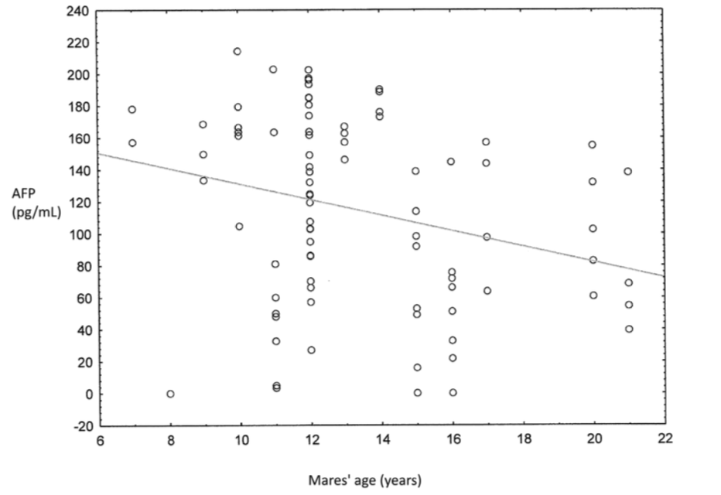

Figure 1:effect of mare's age on AFP concentration in serum (Vincze, et al., 2015)

Number of insemination:
Fertile mares have a higher AFP concentration than less fertile mares (more than 2 inseminations per estrous)
So insemination number had a negative correlation with AFP concentration in the serum.

Effect of gestational age:
AFP concentration in the serum decreases when the gestational age increases which means that mares have lower AFP concentration in their sera at the end of pregnancy than at the beginning.

AFP concentration in normal and risk pregnancy:

In the previous part, we have seen that mares with risk pregnancy have AFP concentration outside the reference values range, either lower or higher in function of the complications encountered during pregnancy.
Here the comparison was quantified and the linear correction was applied which make the results comparable.
The results for the 23 normal pregnancy mares were a mean AFP concentration of 72,93 pg/Ml with a standard deviation of 49,25pg/mL and the standard error of the mean was 10.27.
For the complicated pregnancy mares, the values were really higher with a mean of AFP concentration of 152pg/mL, a standard deviation of 36,48 pg/Ml and a standard error of the mean was 18,6

Effect of mare’s origins and foal sex on AFP concentration in the serum:
After recorded the gender of each fetus at foaling, they concluded that the corrected AFP levels compared between each mare was not function of fetuses’ gender, there was no significate difference between colt and filly.
The mares were born from 26 different dams and 14 stallions. The AFP concentration could be compared within the individual mares, a statistical analysis shown that dam’s mare could have an impact on AFP concentration value in the serum (P-values is inferior to 0,1 which mean that it’s possible that dam’s mare has an impact on AFP concentration in mare)
The stallion is not responsive a significant difference on APF concentration in his daughter.

3-3) discussion

Delivery of healthy foals with mares in good health after foaling are huge economic aspect in equine reproduction. It’s why it’s important to elaborate efficient, fast and non-invasive method to diagnosis risk pregnancy in mare.
AFP concentration in mare’s serum is correlated with viable parameters of the foal and clinical status of the mare (risk or normal pregnancy) (Sorensen, et al., 1990) and also variable like mare’s age, number of insemination, origins, gestational age.
To used that informative marker of fetal well-being for diagnosis method in equine reproduction, a reference data base with normal value of AFP during gestation was made by Doctor Vincze and her colleagues on Lipizzaner mares.
Five groups of mares have to be distinguished in the evaluation of AFP concentration in serum: normal pregnancy, twins, conception failures, placentitis and embryonic loss.
Mares with twins, placentitis (or other placental abnormalities) and embryonic loss have higher AFP values compare to normal pregnancy mares (Sorensen, et al., 1990) so in case where AFP value in serum is higher than reference one furthers investigations should be done to evaluation the risk of pregnancy and to treat it if possible. Mare with lower value should be check by ultrasound to be sure that she is pregnant and she didn’t fail to concept.
That increasing of AFP in mare serum in adverse pregnancy could be explained by the fact that AFP is produced in the fetus (yolk sac then liver) and due to fetal stress, vascular permeability increased and there is more AFP leakage in mare’s serum. In case of late abortion, the increasing of AFP is certainly due to the resorption into the mare blood of the embryo and the yolk sac. In case of twins, it’s the double fetus which produced more AFP and if there is reduction of one of them, AFP concentration in mare’s serum will return in the reference range values soon.
Unfortunately, it’s not possible to differentiate pregnancy problem on the basis of AFP concentration, an increasing of AFP in mare’s serum is a sign of fetal distress but it’s still not possible to evaluated without examinations if it’s placentitis, twins, embryonic loss .. (Vincze, et al., 2015)
Some recent studies have pointed that AFP concentration is really higher in mare suffering from placentitis which is “the leading cause of pregnancy loss in mares and neonatal death within the first 24 hours of life. Foals that do survive to parturition still have hurdles to overcome; many are born with a life-threatening infection called sepsis. Sepsis in foals has a high mortality rate and requires highly specialized, labour-intensive care. Identifying disease and making the decision to treat these foals, however, can be challenging due to the subtlety of early clinical signs.” (Beckstett, 2016)
AFP is detected in foal during all pregnancy even in the third trimester, we already saw that AFP concentration is increased in mare’s serum in case of placentitis but here the hypothesis was done that AFP is also increased in septic foals and foals suffering from neonatal disease. A reference range value was determined for AFP concentration in healthy born foals and AFP levels were significantly higher in the septic group when compared to the healthy group. AFP may serve as a useful marker that can be utilized to assess neonatal health soon after birth. It’s present in high concentrations in fetus and newborn foal in case of sepsis (Beckstett, 2016) and in mare’s suffering from placentitis, so it could be a good diagnosis method to prevent neonatal losses in horses.
Finally, AFP concentration in mare’s serum, in fetus and just born foal’s plasma sounds to be a good non-invasive method to diagnose fetal well-being. However, many factors have to be include in the analysis and to make a reference range value for normal pregnancy mares like mare’s age, gestational age, fertility. Consideration about breeds should be done in the future to investigate if the values from Lipizzaner mares which is old baroque breed of horses would be the same for ponies, sport horses, draft horses…

Part 2: Evaluation of fetal and maternal heart rate in the horses

In equine obstetric the goal is to have healthy foal and mare after parturition. Since 40 years studies have been conducted to find method which could help to determine health parameters of the foetus during gestation. Unfortunately, it’s hard to have access to foetal health during pregnancy. Therefore, it is difficult to determine the well-being of the foetus so it is more useful to study the dam–foetus unit, the two components of which cannot be separated either in space or in any other dimension (Vincze, 2015).
Ultrasound monitoring is the most used method in equine reproduction and can reveal important health information about unborn foals but it’s an invasive method and not always easy to practice on some difficult mares. A complementary method using heart rate and heart rate variability has been evaluated in the last 15 years. It’s a non-invasive method which could be helpful in monitoring unborn foals’ health.

2-1) Why heart rate and heart rate variability measurement in mare and fetus are a good method to access to fetal well-being?

Recent knowledges reveal that “monitoring fetal heart rate(FHR) and fetal heart rate variability(FHRV) helps to understand and evaluate normal and pathological condition in the foal (Baska-Vincze, et al., 2015).
So foetal electrocardiogram (ECG) is an important tool, in addition to transrectal or transabdominal ultrasounds, for monitoring high-risk pregnancies and assessing their potential outcomes," said Christine Aurich. But first it’s important to give a precise definition of FHR and FHRV and why it’s useful to access foetal well-being during pregnancy. The foetus’ heart rate (or HR) can tell veterinarians about the unborn foal’s health status at the precise moment of monitoring. But heart rate variability (or HRV) gives a broader and possibly more accurate look at foetal well-being and it doesn’t require an ultrasound probe, so it’s less invasive and easiest to used. “HRV numerically expresses and describes the variability in heart rate between two consecutive beats, caused by the influence of the neuroendocrine system. The heart rate is not constant even in a healthy animal or at rest, as the distances between two consecutive R waves (the RR intervals) are not the same. The reason for this is that the heart is under the influence of the neuroendocrine system and the vegetative nervous system. The function of this highly complex, multi-step system is to maintain the physiological arterial pressure. Thus, HRV numerically expresses the neuro-hormonal effect exerted on the heart rate. In general, it can be stated that the higher the HRV, the healthier the heart (Bowen, 2010).” (Baska-Vincze, et al., 2015). So HRV is a function of foetus activity, external stressor and HR. It’s sound to be a good parameter to evaluate foetal well-being and stress as explained by Kovács and his team “the measurement of HRV was reported to be an accepted method for assessing the level of stress, as during stress the activity of the sympathetic nervous system increases and certain HRV values change” (Kovács, et al., 2012) . In addition, HRV describes how HR changes, sometimes slowing, sometimes speeding up, including how often and to what extent it changes. And that can provide critical information about health and welfare, including stress. (Baska-Vincze, et al., 2015). In equine fetuses, HR changes significantly over the course of the pregnancy, and it can even vary dramatically from one healthy fetus to another. Further, when a fetus moves, that movement will affect the HR at that specific moment. With ultrasound machines, the movement of both the mare and the fetus could obstruct proper HR readings. On the other hand, HRV detected with an external monitor could be a more reliable tool than HR measurements in horses, even if it won’t replace ultrasounds entirely. So measurement and evaluation of FHR are precious information for the veterinarians as the fetus responds to the decrease of oxygen supply in a manner completely different from the response of adult animals. In adult humans and domestic animals, tissue hypoxia triggers a dramatic increase in heart rate and respiratory rate in order to supply the organs with sufficient oxygen. For the fetus, however, it is not possible to increase the volume of blood and oxygen delivered to the uterus. First the fetal heart rate decreases, in order to reduce the work of the heart and the oxygen demand of the myocardium. Simultaneously, vasoconstriction occurs in the organs to make sure that the brain, the heart and the adrenal glands get sufficient oxygen. All this is possible because the fetus can tolerate a short-term hypoxaemia without sustaining any damage. In fetuses with an intact central nervous system the placental perfusion slows down, increasing the amount of oxygen reaching the fetal blood circulation. If decreased oxygen supply persists, the fetus is forced to make further adaptations. Certain processes (such as growth, anabolic processes, movement) are not necessary for short-term survival. Through a mechanism that is yet unclear, the fetus can temporarily arrest these processes for the duration of hypoxemia. The fetus responds to the stress caused by hypoxia with bradycardia and with the absence of fetal respiratory and other movements. If the insufficiency of oxygen supply is aggravated further or persists, compensatory mechanisms aimed at maintaining the minimum perfusion will be triggered, resulting in tachycardia which is not accompanied by movement activity. When the myocardium becomes exhausted, bradycardia develops again, immediately prior to death (Polin & Fox, 1991; Adamson, 1999).

2-2) Measure of feto-maternal heart rate and results
ECG examination is nowadays a routine exam in horse’s medicine but feto-maternal ECG is a new method in the practice of equine obstetric, it’s allowed to have access to heart rate and heart parameters of the mare and her fetus. It’s started to be used quite recently by veterinarians. The telemetric ECG systems is used to record both ECG (mare and fetus), it can detect fetal signal of the heart from 121days. A filter is added to enhance the fetal heart recordings, and can consistently detect the cardiac activity of unborn foals as said Doctor Baska-Vincze and her team. It’s a good progress because earlier it was not possible to detect fetal signs before 173 days of pregnancy (Nagel, et al., 2011)
Telemetric ECG extracts the timing of the foetal R-Waves from the mare’s abdominal ECG signal by using the mare’s ECG as a reference and in contrast to other methods (of monitoring the pregnancy, such as transrectal palpation or transabdominal ultrasonography), which show only a short period, the fetal ECG can be used for long-term monitoring so that it is possible to get a good evaluation of the fetal well-being (Nagel, et al., 2011).
In case of risk pregnancy, it’s important to record long-term Feto-maternal ECG to decreased external factors which could affect the feto-maternal ECG and have a better access to fetal well-being. Thanks to a fastening system, the mare can stay free in her box during recording and the records can be as short as five minutes (which is what the researchers recommended) or as long as 24 hours, if needed for further analysis.
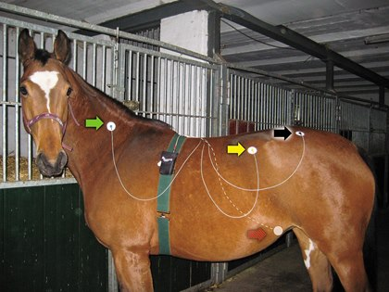
Figure 2;electrodes for feto-maternal ECG registrations

To analyse HR and HRV from the feto-maternal unit, a good quality ECG is essential, for this the mare need be in confidence (familiar place and grooms), stressors factor which can lead to artefact and non-valid results must be kept to a minimum.
ECG recordings can be analyzed for HRV in different ways, e.g. according

to the time domain, the frequency domain and in a non-linear manner. Time domain analysis is the most common, as it allows the analysis of recordings of both shorter and longer duration, and the result is relatively independent of artefacts. “Clinically, this analysis has proved to be the most useful in horses. The two most important parameters belonging here are the standard deviation of normal-normal intervals (SDNN) and the root mean square of successive differences (RMSSD). The former depends on the regulatory effect of the sympathetic and the parasympathetic nervous system, while the latter reflects the long-term variability of heart function and its value primarily depends on the parasympathetic tone” (Kovács, et al., 2012; Baska-Vincze, et al., 2015).Frequency-domain analysis allowed the differentiation of different elements of the neuroendocrine system and their effects on the cardiovascular system. Within this system, three factors influence cardiac function: the renin angiotensin-aldosterone (RAAS) system that acts on the heart rate for a longer period of time (seconds or minutes), the sympathetic nervous system (seconds) and the parasympathetic nervous system (during the RR interval). This method of analysis differentiates three frequency domains: a high-frequency, a low-frequency and a very low frequency range. Within the frequency-domain analysis, the so-called LF/HF ratio, which is an indicator of sympathetic-parasympathetic balance and sympathetic activity, is very important. If the animal is exposed to stress of shorter or longer duration, the HF part decreases and thus the LF/HF ratio increases (Kovács, et al., 2012).

Some studies have recorded results of feto-maternal ECG, it’s the case of Nagel and her team who monitored seven Warmblood broodmares (aged 5 to 20 years) and their foetuses during the last two months of pregnancy and parturition in 2010 with ECG equipment to gain a better understanding of how the two cardiovascular systems function together and Baska-Vincze and her team who studied 17 Lipizzaner broodmares and their foetuses in 2014. The recorded ECG is presented like the fallowing figure (Figure 3) then the reading of it allowed to calculate different parameters (HRV, HR, SDNN..) which can be analyse after for accessing fetal well-being.

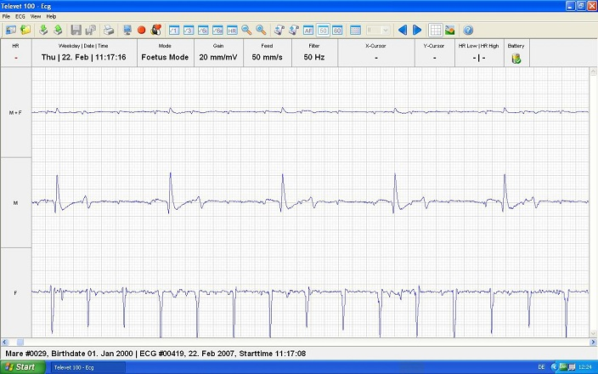

Figure 3; feto-maternal ECG

The results of the monitoring of feto-maternal unit of horse in the case of the 17 Lipizzaner broodmares are the following:
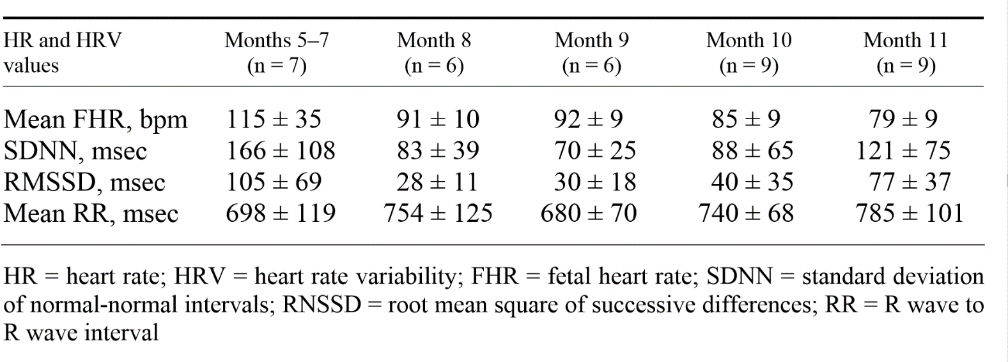
Table 2 heart rate and heart rate variability values in equine fetus during the second part of gestation (Baska-Vincze, et al., 2015)
The mean FHR (P = 0.004) and the standard deviation of FHR (P = 0.012) significantly decreased during the pregnancy; the FHR ± SD values decreased from 115 ± 35 to 79 ± 9 bpm during the ongoing pregnancy.

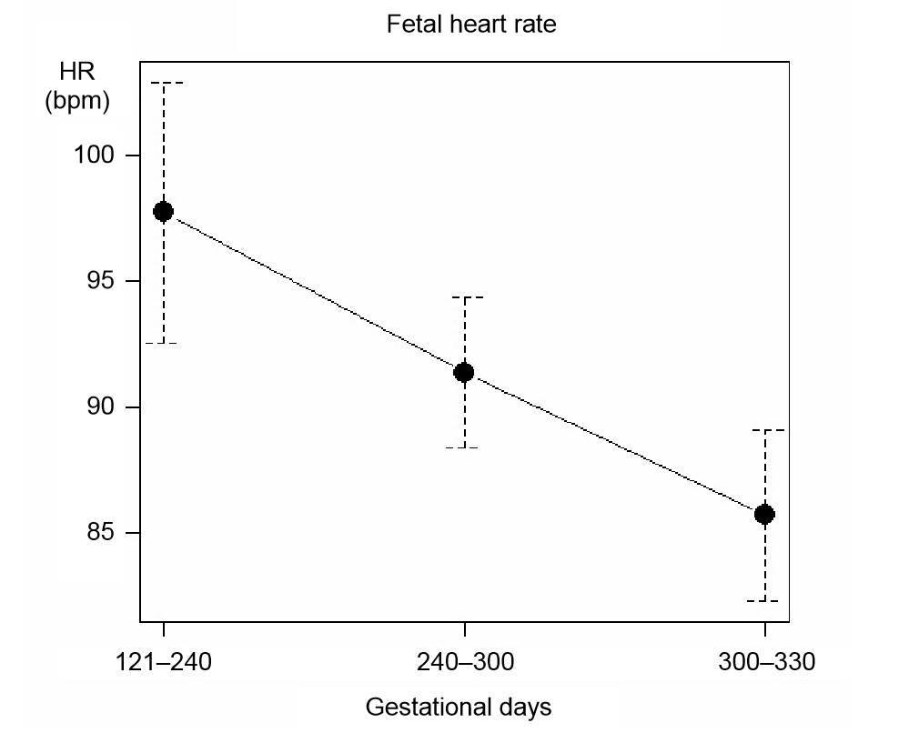
Figure 4:a plot of mean showing fetal heart rate decreased from121 days of gestational age
The RR intervals compared to the gestational days tended to increase during pregnancy, but this increase was not significant (Baska-Vincze, et al., 2015). SDNN and RMSSD tended to decrease but their decrease did not reach the level of significance Figure 5.

Figure 5: important fetal heart parameters in ms (without standard deviation included in the values)

In addition, the large differences they studied four mare-fetus pairs for four consecutive months and it’s support the assumption that there might be ‘high-HR’ and ‘low-HR’ fetuses in horses.
Nagel’s results were tendency the same but from their measurements they concluded that FHR continuously decreases while FHRV increases with the advancement of gestation” In mares, the RR interval decreased from 1480 ± 29 ms on day 270 of pregnancy to 1190 ± 58 ms on day 330 of pregnancy (p < 0.05). In contrast, foetal RR(HRV) interval increased during the same time period from 611 ± 23 ms on day 270 of gestation to 756 ± 25 ms on day 330 of gestation (p < 0.05). Concomitantly, maternal HR increased and foetal HR decreased.” (Nagel, et al., 2011)

2-3) Discussion:

The last decade, studies have shown that feto-maternal ECG, FHRV, and FHR is a good non-invasive method which can be easily performed in a stud condition, so mare are keeping in familiar condition which prevent external stressor. Data analysis inform veterinarians about fetal well-being either in 5 min (Short record) or as long as 24 hours (long records).
It’s important to keep a quiet mare otherwise the result could be false because the stress increases blood cortisol which could affect HR and HRV values of the mare and cortisol can cross placenta and could also affect heart parameters of the foal.
Important data have been collected during mare’s pregnancy and the analysis of them give a general view of the normal feto-maternal ECG values.
Overall, there are no significant increase in the mares' heart rates throughout pregnancy just slightly during the last month. The heart of most fetuses decreased in the last month from about 110 beats per minute (BPM) and to around 80 BPM (Nagel, et al., 2011)and during delivery some foals' heart rates dropped to 50 BPM during delivery (which could explain why prolonged delivery is very dangerous for foal life. In the study on Lipizzaners the mean FHR significantly decreased and the mean RR intervals (as on Nagel’s study) tended to increase (but it was not significant) during the pregnancy. However, the standard deviation of FHR (SDFHR) significantly decreased in relation to gestational age, these data showed that HRV in the foal fetus decreased as the pregnancy progressed, which is in contrast with the results of earlier equine studies (Nagel, et al., 2011). “As HRV has been reported to decrease in horses under certain conditions such as stress, pain and fetal distress (Bowen, 2010) , it is an important question to wonder why FHRV decreases in foal fetus or if it’s just is a physiological decrease of FHRV during maturation as describe in human medicine. “It has been described that HRV is influenced by HR and a higher HR is generally associated with a lower HRV. In horses, fetal HR in months 5–11 of gestation is approx. between 115 and 80 bpm; therefore, the decreasing HRV observed during pregnancy cannot be explained by this fact. In human medicine, there have been detailed studies on the fetal maturation process and its effect on HR and HRV, and HRV parameters are also available for human fetuses. However, in the case of pregnant mares and their fetuses this is a relatively new field of perinatology and only limited information is available for researchers” (Baska-Vincze, et al., 2015).So feto-maternal ECG is a very promising tool for assessment of fetal well-being but some more research has to be done to evaluate a larger sample and study if there is inter-breed difference in fetus’ cardiac parameters.

Conclusion

Breeding a mare is an exciting and painstaking goal for horse owner. A healthy foal results from years of planning, preparation, and financial and emotional investment: selecting the perfect stallion, working with breeding managers and veterinarians, settling and confirming the mare’s pregnancy, and ensuring a healthy gestation and foaling. With all the effort breeding requires, losing the pregnancy, the new-born foal, or even the mare is a devastating prospect. Identifying high-risk pregnancies early can help safeguard against those losses. New diagnostic method like Measurement of AFP in pregnant mare serum or evaluation of feto-maternal ECG in sound to be very promising tool in equine obstetric to access to fetal well-being in equine.
As we have seen AFP dosage in maternal serum just requires a blood sample and then dosage is made with Elisa test which in not very expensive and fast to realise. This method allowed to sample many mares in once time in a stud and then just mares who have values outside the reference range should be investigate with ultrasound or other methods to exclude risk pregnancy. This method is also very useful to diagnose early (as soon as 12 days) twin pregnancy which can lead to loss of mare and both fetus. After reduction of one fetus, dosage of AFP in mare’s serum ensures that reduction was well-done and that just one fetal is present.
Feto-maternal ECG and fetal heart parameters give very precious information about fetal stress and growth, Nagel believes that reference baseline values could be useful for detecting fetal or maternal stress during pregnancy, as large variations in HR or HRV in either the mare or the fetus could be indicative of a problem. In case of risk pregnancy,
it should be used to evaluate fetal distress as often as 30 in a day (Nagel, et al., 2011)
Both of these methods sound to be promising in equine obstetric but there is still research to do on both to get complete reference range values which would include more computing like interbreed difference.
Furthermore, an important aspect is that AFP concentration or FHR are easy methods which can be applied in the daily routine of a veterinarians and at the farm.
It’s also a non-invasive method for the mare which prevent from stressing her too much. These methods could be associate with other non-invasive one for diagnosis fetal well-being in equine like haematological and biochemistry analyses from maternal blood or ultrasound to get a complete profile of the equine fetus’ health.

Bibliography

Adamson, S. L., 1999. Arterial pressure, vascular input impedance, and resistance as determinants of pulsatile blood flow in umbilical artery. Eur J Obstet Gynecol Reprod Biol., 2(84), pp. 119-125.
B. Camoretti-Mercado, L. M. B. M. e. a., 1987. Developmental regulation of rat alpha-fetoprotein gene in transgenic mice. Regulation of Liver Gene Expression »,. Cold Spring Harbor, Cold Spring Harbor Laboratory, p. p 104.
Bakker, J. et al., 2006. Alpha-fetoprotein protects the developing female mouse brain from masculinization and defeminization by estrogens. Nature Neuroscience 9, pp. 220-226.
Baska-Vincze, B., Baska, F. & Szenci, o., 2015. Fetal heart rate and fetal heart rate variability in Lipizzaner broodmares. Acta veterinaria Hungarica , Volume 63, pp. 89-99.
Beckstett, A., 2016. Can Alpha-Fetoprotein Help Diagnose Neonatal Disease?. [En ligne]
Available at: http://www.thehorse.com/articles/38031/can-alpha-fetoprotein-help-diagnose-neonatal-disease
[Accès le september 2016].
Bowen, I. .., 2010. Ambulatory electrocardiography and heart rate variability. Dans: c. MARR, éd. Cardiology of the Horse ,2nd ed. edinburg: Saunders Ltd, pp. 127-137.
Kovács, L. és mtsai., 2012. Heart rate variability as a measurement of stress in cattle: biological background, methods and results. Literature review. Magyar Állatorvosok Lapja, Issue 134, pp. 515-523.
Nagel, c., Aurich, j. & Aurich, c., 2011. Heart rate and heart rate variability in the pregnant mare and its foetus. reproduction in domestic animals, Volume 46, pp. 990-993.
Polin, R. A. & Fox, W. w., 1991. Fetal and Neonatal Physiology. London : Elsevier Health Sciences .
Sorensen, K., Neely, D., Read, W. & Grappel, P., 1990. Measurement and clinical significance of equine alpha-foetoprotein. journal of equine veterinary science, pp. Volume 10, Issue 6, Pages 417–421.
Vincze, B. et al., 2015. : Equine alpha-fetoprotein (eqAFP) levels in Lipizzaner mares with normal pregnancies and with pregnancy loss.. theriogenology.
Vincze, B. N., 2015. STUDY OF THE HEALTH STATUS OF EQUINE FETUSES, Budapest: s.n.

ACKNOWLEDGEMENTS
The accomplishment of his thesis would not have been possible without the help of some persons whom I would like to thank!
Dr. Vincze Boglárka PhD, who help me during the whole process and gave me the opportunity to work on this thesis.
Thank to Mam and Dad who gave me the love of animals and allowed me to reach the end of my dreams.
Thank to my “little family” in Hungary who make that five years incredibly short: Robin, Mo, Franzi, Clémence, Ana, camille, Perrine and many others.
Thanks to my ‘heart sisters ’who have always been with me during the best and the worst moments: Laura and Cécile .
I finally would like to thank my French friends who have never forgotten me despite the distance and always supported: Charlène, Marion, Caroline, Nono, Manon and J M.
Thanks to all of you, thank to have make my dream a reality.

